MAN2MAN GROUP
Monday (7 pm)
Faith, Fellowship, Food, & maybe “watching” football.
CHURCH COUNCIL
Tuesday (7 pm)
CARPET CLEANING
Wednesday
The church will be closed on Wednesday as the building will be undergoing carpet cleaning throughout.
TURKEY SUPPER
Saturday, November 6th
It’s that time of the year! Plan on volunteering and attending this year’s Turkey Supper. For more information on how you can help, please contact the church office.
**We need people willing to bake turkeys at home, provide desserts, help with set-up, serving, etc.
DART BALL
09/29/2021 @ Matteson (8 pm)
The dart ball team will be on the road this Wednesday.
09/26/2021
W E L C O M E
Connecting with God!
We are thankful that you are here today!
It is our prayer that today’s service provides you a way to connect with God and other believers.
UPCOMING EVENTS
BIRTHDAY CARD!

Please take a moment to sign the Birthday Card for Louise Sievers on the table in the back of the sanctuary.

Louise will turn 91 on October 1st!

ANNIVERSARY SUNDAY
October 3rd, 2021

Make plans now to join us for our special service celebrating our past history and preparing for our future!

Ringing of the Bell
Prelude “In the Garden”
Welcome & Announcements
Call to Worship & Opening Prayer
Song of Worship “Because He Lives” #447
Old Testament Reading Psalm 34:17-19; 112:6-8
Children’s Moment
Song of Praise “Just a Closer Walk with Thee” #504
Pastoral Prayer & Lord’s Prayer
Responsive Song “How Lovely, Lord, How Lovely” #545
New Testament Reading Selected verses from Acts
Sermon “The Power of Connection”
Closing Song “The Church’s One Foundation” #544
Benediction
Postlude “Love the Lord, Thy God”

RADA CUTLERY

We are having a special fundraiser for our church – purchase useful items for yourself or plan ahead for birthday or Christmas gifts.

RADA Cutlery has more than just utensils – check out a catalog in the church office or on one of the tables inside the sanctuary.

You won’t want to miss this special service!

Judy Lange will be our special speaker. There will also be a few other surprises during the service.

Additionally following the service, we hope to un-earth at least one of the two time capsules buried on the church property.

It’s going to be a great day – hope you can join us.
Order of Service
Celebrating Over 150 Years!!!

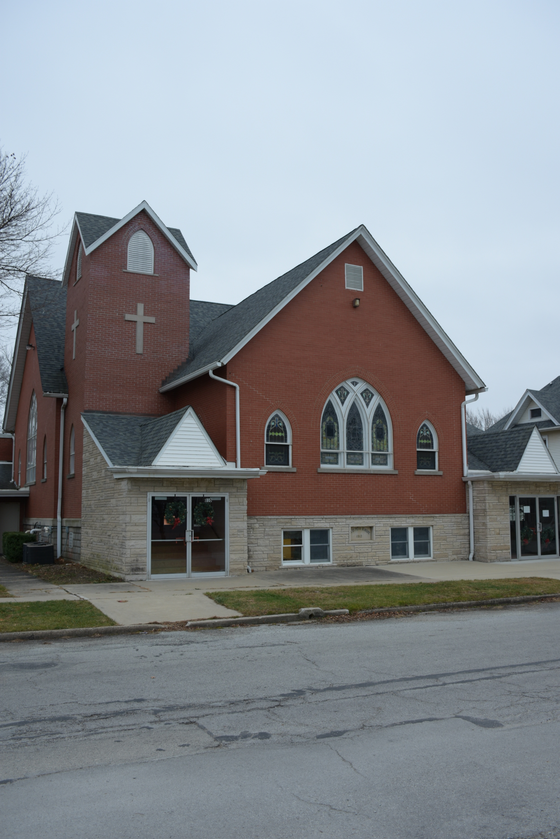
OTHER ANNOUNCEMENTS

Christian Education Classes: We believe Christian Education is vital to being a healthy Christian and congregation. We strongly encourage you to participate in one of the opportunities listed below:
Children – Youth (9 am) – There are classes for Preschool – 4th Grade, 5th – 8th Grade, and 9th – 12th Grade. Please let us know if you have any questions as to where the classes meet.
Adult Sunday Class (9 am) - Bad Characters in a Godly Person – We will meet on Sunday mornings from 9 am – 10 am in the Clyde Lange Fellowship Hall. Coffee (and maybe treats) will be provided.
Online (Virtual) Class – Are you busy? We understand! This opportunity is designed for you to work at your own pace. To receive a weekly lesson/lesson plan, please email Pastor Kyle Timmons at pastorkyletimmons@live.com.
Man-to-Man Group – Faith, Fellowship, Food, and maybe Football. ALL men are welcome to join us on Mondays at 7 pm. We will discuss some books (don’t worry, you don’t have to buy/read the book if you don’t want to) written by Retired LTG William G. Boykin, former Commander of the U.S. Army Special Forces. There will be great fellowship, plenty of food, and if you want to stay and watch football with us that evening, you may do so as well.

Please be in prayer for:

Gary Ekhoff, Gene Sievers, Carter Fortin, Mason Beseke, Austin Delaney, Linda Havely, Taylor Cleary, Nancy Lewke, Dennis Balgemann, Joy Currier, Cheyenne Jones, Donna Dorrough, Patrick Pahl, Ken & Sandy Erickson, the family of Johnny Loitz, and the family of Ryan Ohm.

Serving You Today

Minister: Kyle Timmons Council President: Max Toppen
Organist: Judy Schneider Vice President: Brian McKinstry
Lay Reader: Karen Brunello Secretary: Heidi Frahm
Greeters: Kevin & Debbie Mussman Treasurer(s): Michelle Claussen
Karen Ekhoff
Other Council Members:
Rhiannon Currier, Carrie Langlois, David Lehnert & Larry Voigt
St. Peter's
United Church of Christ

Order of Worship - September 26th, 2021

Christian Education Hour – 9:00 am
Worship Service – 10:30 am
Church Office – (815) 465-6191
Website: www.stpetersgp.org
Email: stpetersgp@sbcglobal.net
Facebook: St. Peters UCC Grant Park

St. Peter’s United Church of Christ
P.O. Box 220 – 306 N. Meadow Street (Grant Park, IL) 60940
PHONE: (815)465-6191 www.stpetersgp.org

