MAN TO MAN GROUP
Monday (7 pm)
Faith, Fellowship, Food, & maybe “watching” football.
CHRISTIAN EDUCATION MTG.
Tuesday (7 pm)
DART BALL
Wednesday @ Peotone (8 pm)
The dart ball team will be on the road this Wednesday.
CONFIRMATION CLASS
Sunday, October 10th
Class will meet following the worship service!
TURKEY SUPPER
Saturday, November 6th
It’s that time of the year! Plan on volunteering and attending this year’s Turkey Supper. For more information on how you can help, please contact the church office.
**We need people willing to bake turkeys at home, provide desserts, help with set-up, serving, etc.

UPCOMING EVENTS

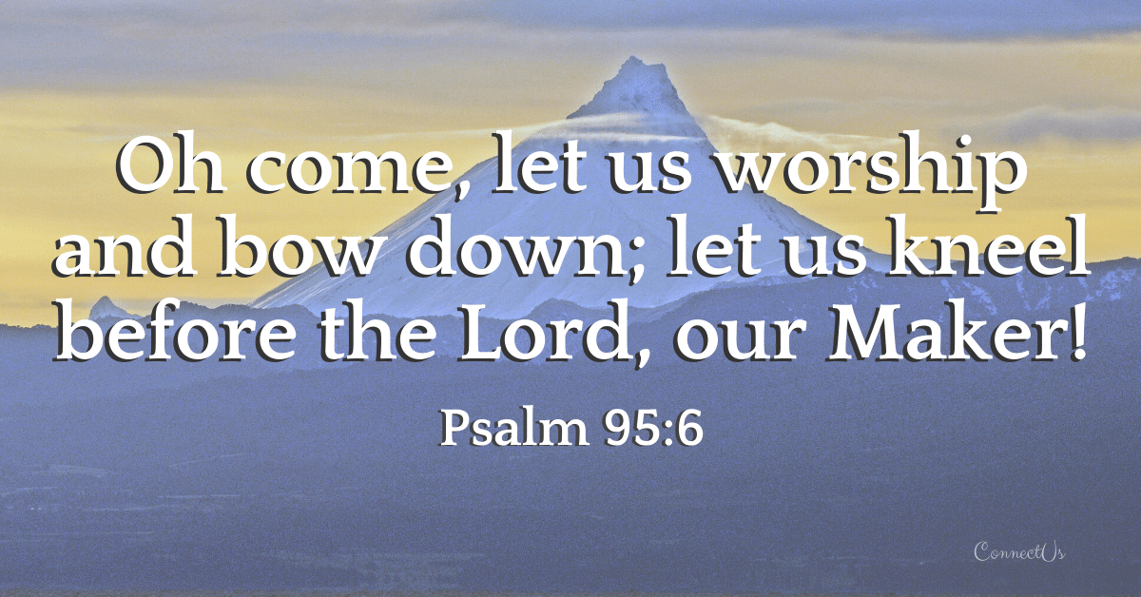

10/03/2021
W E L C O M E
Year-to-Date Giving Update

Giving Thru August: $124,157
Spent Thru August: $115,336

*Giving includes the government PPP Loan of $24,000. Actual giving is about $15,000 below expenses.

RADA CUTLERY

We are having a special fundraiser for our church – purchase useful items for yourself or plan ahead for birthday or Christmas gifts.

RADA Cutlery has more than just utensils – check out a catalog in the church office or on one of the tables inside the sanctuary.

Order of Service
Ringing of the Bell
Choir Anthem/Prelude “Bless the Lord”
Welcome & Announcements Kelly Toppen
Call to Worship & Opening Prayer
Opening Song “Joyful, Joyful, We Adore Thee” #59
Scripture Reading Psalm 91:1-16 Kelly Toppen
Worship Through Giving (Offering) “Video Presentation”
Children’s Moment
Pastoral Prayer (Joys & Concerns) Pastor Kyle
Choir Anthem “Simple Gifts/Pachelbel’s Canon”
Time of Recognition
Song of Thanksgiving “Now Thank We All Our God” #14
Message Judy Lange
Service of Communion (see back)
Closing Words Pastor Kyle
Closing Song “Holy, Holy, Holy” #136
Spoken Benediction
Benediction in Song “Let There be Peace on Earth”
Postlude

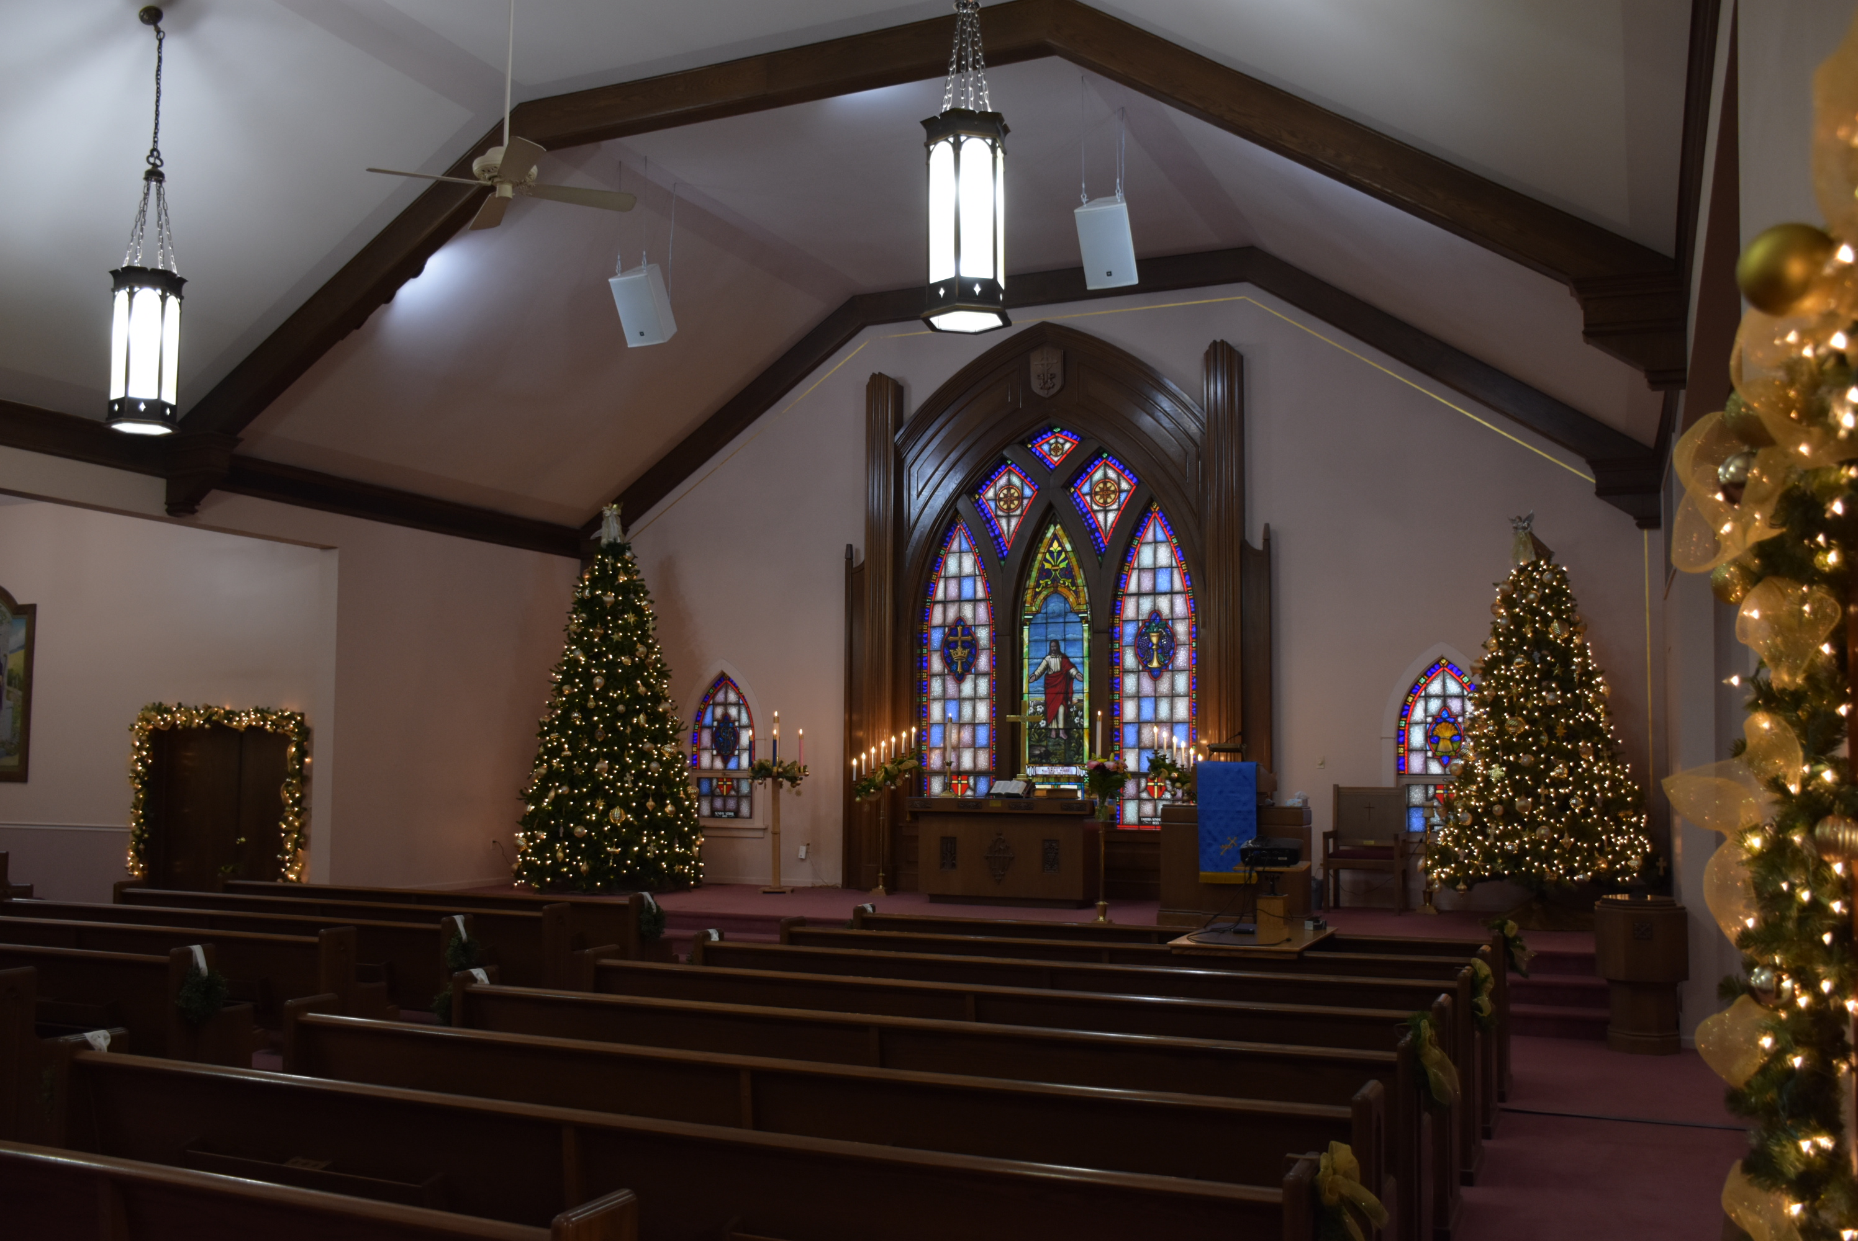
Celebrating 151 Years!

“For the Lord is good! His steadfast love endures forever, and His faithfulness to all generations.”
Psalm 100:5

Celebrating Over 150 Years!!!

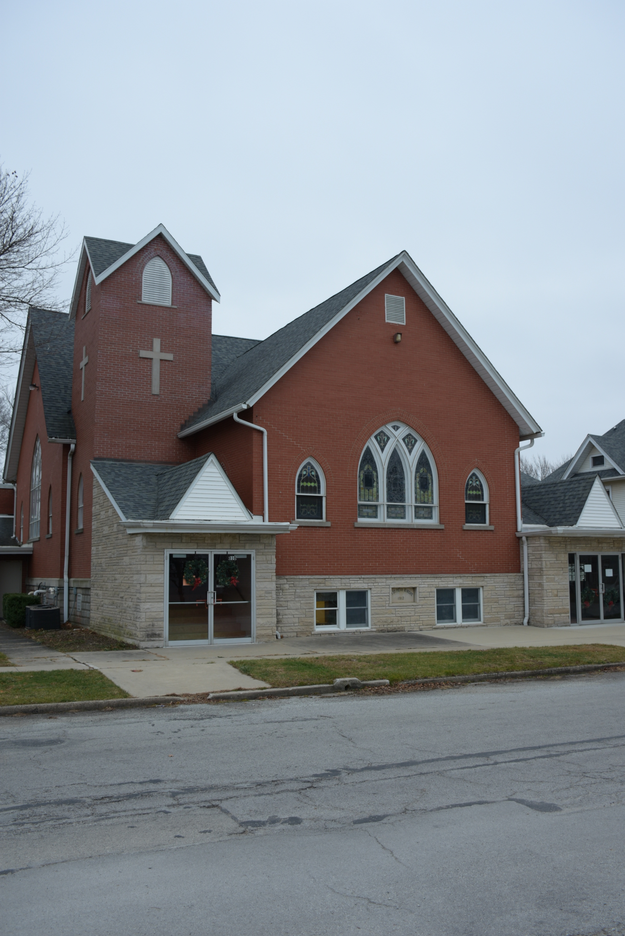
Service of Communion

The Invitation to the Table
The Prayer of Confession and Pardon
Merciful God, we confess that we have not loved You with our whole heart. We have failed to be an obedient church. We have not always done Your will; we have broken Your commandments, we have rebelled against Your love, and we have not always loved our neighbors. Forgive us our sins and guide us into true repentance. May we experience freedom from evil and the bondage of sin. Amen.
The Profession of Forgiveness
The Blessing of the Bread and Cup
The Hymn of Response “One Bread, One Body” #689
The Sharing of the Lord’s Supper
The Prayer of Thanksgiving and Praise

Please be in prayer for:

Gary Ekhoff, Gene Sievers, Carter Fortin, Mason Beseke, Austin Delaney, Linda Havely, Taylor Cleary, Nancy Lewke, Dennis Balgemann, Joy Currier, Cheyenne Jones, Donna Dorrough, Patrick Pahl, Ken Erickson, St. Paul Lutheran Church of Beecher (fire), the family of Johnny Loitz, and the family of Ryan Ohm.

Serving You Today

Minister: Kyle Timmons Council President: Max Toppen
Organists: Judy Schneider/Shari Ohm Vice President: Brian McKinstry
Lay Reader: Kelly Toppen Secretary: Heidi Frahm
Speaker: Judy Lange Choir Director: Ann Smith
Greeters: Steve & Jennifer Radostits Treasurer(s): Michelle Claussen
Carrie & Carlie Langlois Karen Ekhoff

Other Council Members:
Rhiannon Currier, Carrie Langlois, David Lehnert & Larry Voigt
St. Peter's
United Church of Christ

Order of Worship - October 3rd, 2021

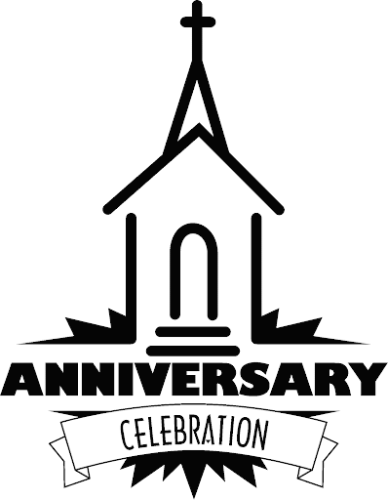

Christian Education Hour – 9:00 am
Worship Service – 10:30 am
Church Office – (815) 465-6191
Website: www.stpetersgp.org
Email: stpetersgp@sbcglobal.net
Facebook: St. Peters UCC Grant Park

St. Peter’s United Church of Christ
P.O. Box 220 – 306 N. Meadow Street (Grant Park, IL) 60940
PHONE: (815)465-6191 www.stpetersgp.org

