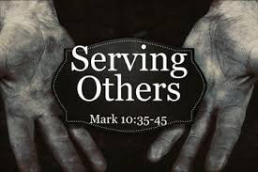

CHOIR PRACTICE
Wednesday (7 pm)
DART BALL
Wednesday @ Manhattan (8 pm)
CONFIRMATION CLASS
Sunday, October 31st – Help with Turkey Supper set-up after church (1 hour)

Saturday, November 6th – Turkey Supper service project.
TURKEY SUPPER
Saturday, November 6th
It’s that time of the year! Plan on volunteering and attending this year’s Turkey Supper. For more information on how you can help, please contact the church office.

**We still need people willing to bake turkeys at home, provide desserts, help with set-up, serving, etc. We have less than half of those needed to roast turkeys and donate desserts.

UPCOMING EVENTS

Year-to-Date Giving Update

Giving Thru August: $124,157
Spent Thru August: $115,336

*Giving includes the government PPP Loan of $24,000. Actual giving is about $15,000 below expenses.

RADA CUTLERY

We are having a special fundraiser for our church – purchase useful items for yourself or plan ahead for birthday or Christmas gifts. All orders are due this Monday, October 18th.

RADA Cutlery has more than just utensils – check out a catalog in the church office or on one of the tables inside the sanctuary.

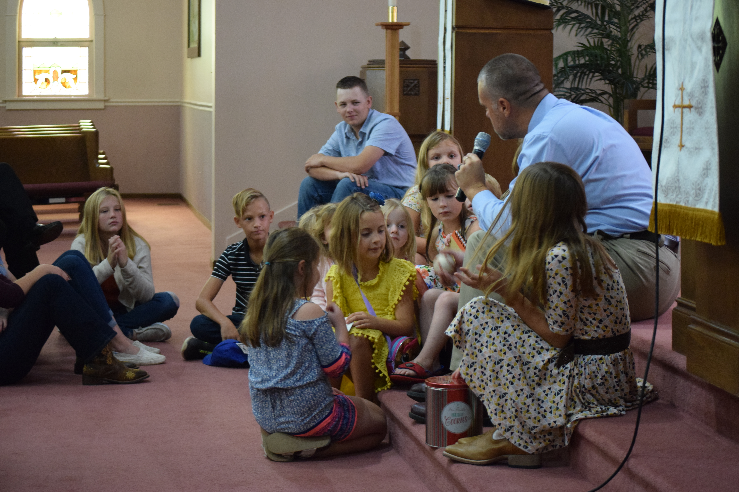
10/17/2021
W E L C O M E
Order of Service
Ringing of the Bell
Prelude “Lift Thine Eyes”
Welcome & Announcements Kevin Mussman
Call to Worship (Back of Bulletin) Kevin Mussman
Opening Prayer Pastor Kyle
Opening Song “Arise, Your Light is Come!” #231
Scripture I Chron. 16:8-15, 23-27, 36 Kevin Mussman
Song of Worship “Glorify Thy Name” #146
Offering
Offertory “He’s Still There”
Doxology #34
Children’s Moment
Pastoral Prayer (Joys & Concerns)
Song of Thanksgiving “You Are My All in All” #427
Scripture Mark 10:35-45
Message “Losers Say What?” Pastor Kyle
Closing Song “Savior, Like a Shepherd Lead Us” #440
Spoken Benediction
Postlude “O Magnify the Lord”

“Give praise to the Lord, proclaim His name; make known among the nations
what He has done.”
I Chronicles 16:8

Celebrating Over 150 Years!!!

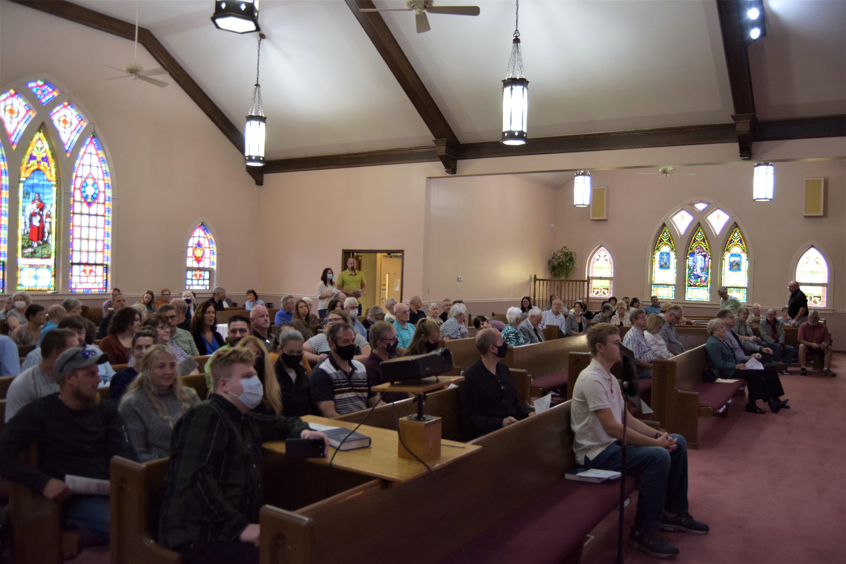
Call To Worship
(based on Psalm 107:1-2, 21-22, 32)

Leader: Give thanks to the LORD, for He is good; His love endures forever.
People: Let the redeemed of the LORD tell their story – those He redeemed
from the hand of the foe.
Leader: Let them give thanks to the LORD for His unfailing love and His wonderful deeds for mankind.
People: Let them sacrifice their offerings and tell of His works with
songs of joy.
Leader: Let them exalt Him in the assembly of the people and praise Him in the council of the elders.
All: Let us declare the mighty deeds of God! Let our lips proclaim that
God’s love endures forever.

Please be in prayer for:

Gary Ekhoff, Gene Sievers, Carter Fortin, Mason Beseke, Austin Delaney, Linda Havely, Taylor Cleary, Nancy Lewke, Dennis Balgemann, Joy Currier, Cheyenne Jones, Donna Dorrough, Patrick Pahl, Ken Erickson, and the family of Ryan Ohm.

Serving You Today

Minister: Kyle Timmons Council President: Max Toppen
Organist: Judy Schneider Vice President: Brian McKinstry
Lay Reader: Kevin Mussman Secretary: Heidi Frahm
Greeters: Max Toppen Treasurer(s): Michelle Claussen
Kelly Toppen Karen Ekhoff

Other Council Members:
Rhiannon Currier, Carrie Langlois, David Lehnert & Larry Voigt

St. Peter's
United Church of Christ

Order of Worship - October 17th, 2021

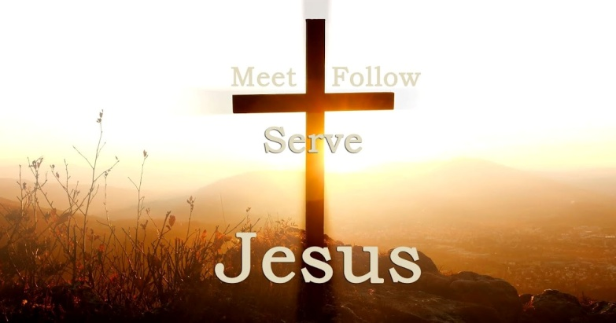

Christian Education Hour – 9:00 am
Worship Service – 10:30 am
Church Office – (815) 465-6191
Website: www.stpetersgp.org
Email: stpetersgp@sbcglobal.net
Facebook: St. Peters UCC Grant Park

St. Peter’s United Church of Christ
P.O. Box 220 – 306 N. Meadow Street (Grant Park, IL) 60940
PHONE: (815)465-6191 www.stpetersgp.org

