DART BALL
Wednesday home v Peotone (8 pm)
CONFIRMATION CLASS
Sunday, October 10th & 31st
Class will meet following the worship service!
TURKEY SUPPER
Saturday, November 6th
It’s that time of the year! Plan on volunteering and attending this year’s Turkey Supper. For more information on how you can help, please contact the church office.

**We need people willing to bake turkeys at home, provide desserts, help with set-up, serving, etc.

UPCOMING EVENTS

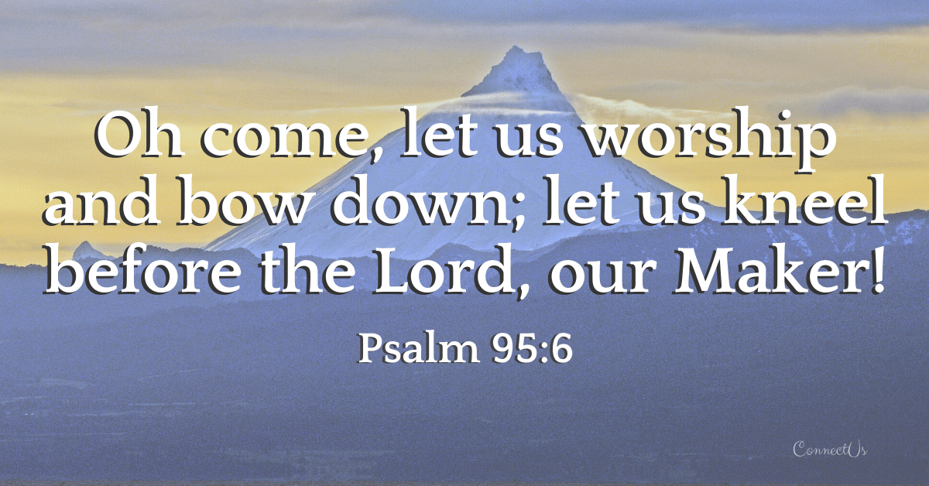

10/10/2021
W E L C O M E
Year-to-Date Giving Update

Giving Thru August: $124,157
Spent Thru August: $115,336

*Giving includes the government PPP Loan of $24,000. Actual giving is about $15,000 below expenses.

RADA CUTLERY

We are having a special fundraiser for our church – purchase useful items for yourself or plan ahead for birthday or Christmas gifts.

RADA Cutlery has more than just utensils – check out a catalog in the church office or on one of the tables inside the sanctuary.

Order of Service
Ringing of the Bell
Prelude “Great is Thy Faithfulness”
Welcome & Announcements Shirley Koehn
Call to Worship Based on Nehemiah 9:6 (See back page)
Opening Prayer Pastor Kyle
Opening Song “Like a River Glorious” #435
Scripture Reading Revelation 21 Shirley Koehn
Song of Worship “Heaven Song” (Wickham) Screen
Offering
Offertory “Now Unto Him”
Doxology #34
Children’s Moment
Pastoral Prayer (Joys & Concerns)
Song of Thanksgiving “Blessed Assurance” #426
Message “A Glimpse of Heaven” Pastor Kyle
Closing Song “When We All Get to Heaven” #525
Spoken Benediction
Postlude “My Faith Has Found a Resting Place”

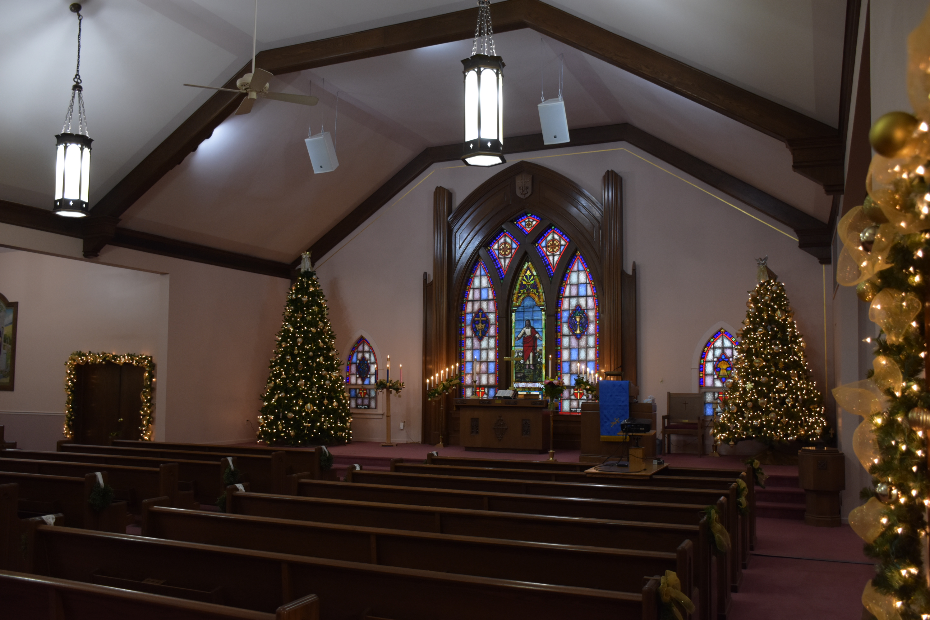

“For the Lord is good! His steadfast love endures forever, and His faithfulness to all generations.”
Psalm 100:5

Celebrating Over 150 Years!!!

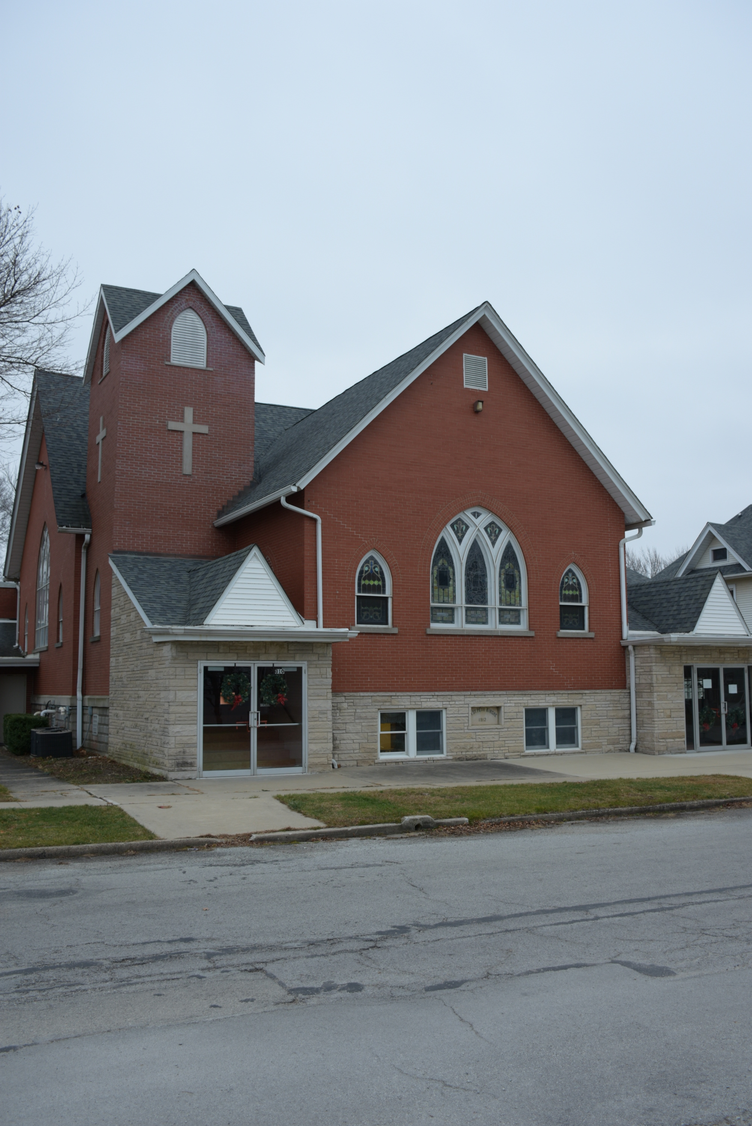
Call To Worship

Leader: Almighty Creator, You alone are the Lord.
People: You made the heavens, even the highest heavens.
Leader: And all their starry host, the earth and all that is in it,
People: The seas and all that is in them.
Leader: You give life to everything
People: And the multitudes of heaven worship You.
All: Let us join with them and worship God’s holy name.

Please be in prayer for:

Gary Ekhoff, Gene Sievers, Carter Fortin, Mason Beseke, Austin Delaney, Linda Havely, Taylor Cleary, Nancy Lewke, Dennis Balgemann, Joy Currier, Cheyenne Jones, Donna Dorrough, Patrick Pahl, Ken Erickson, St. Paul Lutheran Church of Beecher (fire), and the family of Ryan Ohm.

Heaven Song (Phil Wickham)

You wrote a letter and You signed Your name I hear Your voice and I catch my breath
I read every word of it page by page ‘Well done My child, enter in and rest’
You said that You'd be coming, coming for me soon Tears of joy roll down my cheek
Oh my God I'll be ready for You. It’s beautiful beyond my wildest dreams,

(Chorus) I want to run on greener pastures (Chorus x’s 2)
I want to dance on higher hills
I want to drink from sweeter waters No, I can’t wait to join the angels
In the misty morning chill and sing my heaven song.
And my soul is getting restless
For the place where I belong
I can't wait to join the angels and sing my heaven song.

Serving You Today

Minister: Kyle Timmons Council President: Max Toppen
Organists: Judy Schneider Vice President: Brian McKinstry
Lay Reader: Shirley Koehn Secretary: Heidi Frahm
Greeters: Karen Ekhoff Treasurer(s): Michelle Claussen
Russ Koehn Karen Ekhoff

Other Council Members:
Rhiannon Currier, Carrie Langlois, David Lehnert & Larry Voigt
St. Peter's
United Church of Christ

Order of Worship - October 10th, 2021

Christian Education Hour – 9:00 am
Worship Service – 10:30 am
Church Office – (815) 465-6191
Website: www.stpetersgp.org
Email: stpetersgp@sbcglobal.net
Facebook: St. Peters UCC Grant Park

St. Peter’s United Church of Christ
P.O. Box 220 – 306 N. Meadow Street (Grant Park, IL) 60940
PHONE: (815)465-6191 www.stpetersgp.org

