The Keys
St. Peter’s United Church of Christ
Grant Park, IL

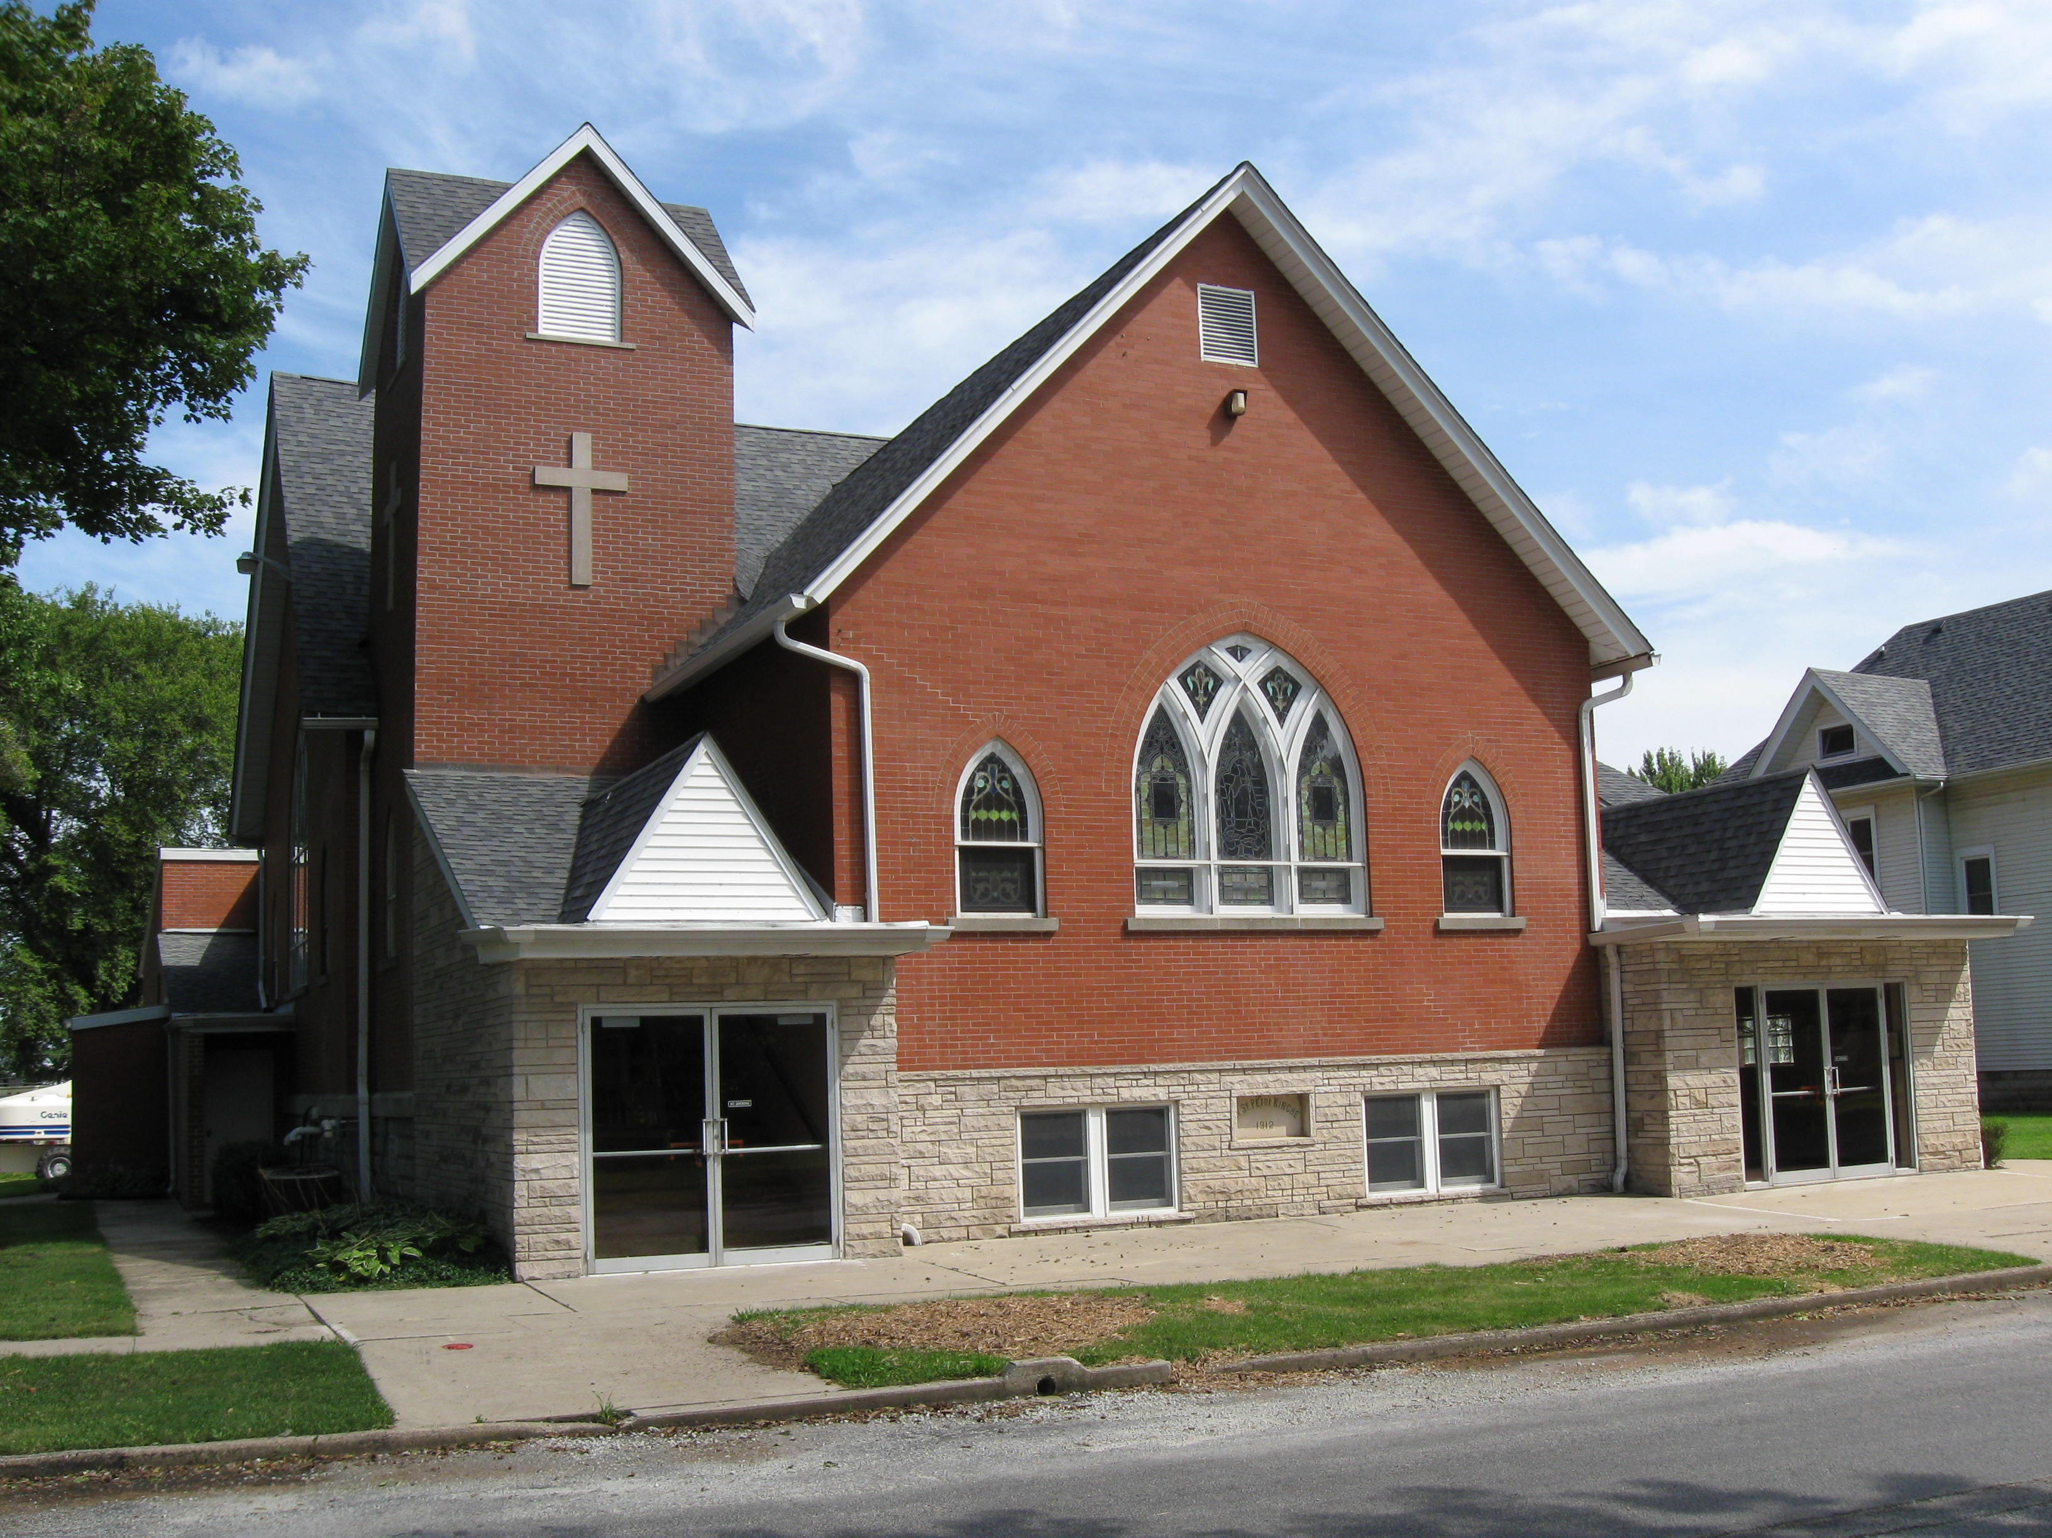

November 2021
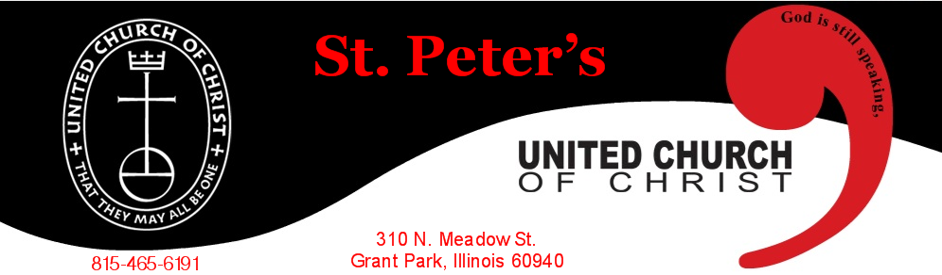
PO Box 220
www.stpetersgp.org

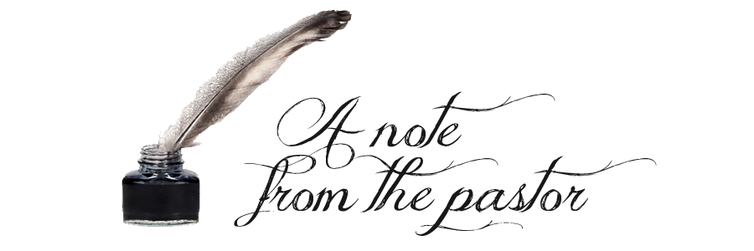

What a celebration it was!

On Sunday, October 3rd, the congregation of St. Peter’s UCC celebrated its’ rich history with a memorable “151st Anniversary” worship service and luncheon.

The sanctuary was full, the music was inspirational, our guest speaker, Judy Lange, was fabulous, and the dinner was outstanding.

There were surprises. One was when Ann Smith, our choir director, walked out with the choir to the choir section and she noticed her entire family present for worship, which was just part of the wonderful service. We also had some surprise visitors as Mrs. Toni Reifsteck, the wife of the late Pastor Wallace Reifsteck (1964-1969), and her son joined us.

Memories were shared from past and present members as Pastor Kyle read their submitted thoughts. Judy Lange’s reflection on the history and faith of those who founded St. Peter’s and all who have come afterwards was intriguing.

More memories, some photos, and additional information about our celebration can be found within the pages of this newsletter. We hope you enjoy.

And while we celebrate our history and enjoy the many memories we have with our congregation, let us not slow down in our participation and faithfulness to our church family. Until Christ returns, there is work left to be done!

Reverend Kyle J. Timmons
Reverend Kyle Timmons
Words of Appreciation


Pastor Kyle – Thank you and members (of St. Peters) for putting on a beautiful 150th Anniversary of St. Peters’. The sermon from Judy, the pictures, the words from when you were drinking from the cup (communion), and the songs all were very moving and touched our hearts deeply.
Bob Chesterfield & Evelyn Bond
To church council and the members of St. Peter’s UCC – Thank you very much for your generous gift card to Texas Roadhouse (my favorite) and your card in honor of Pastor Appreciation month. It has been a wonderful privilege to serve St. Peter’s UCC and the community the last three years.
Pastor Kyle Timmons
St. Peter’s UCC would like to thank the United Methodist Church for their generous gift of the bird bath for our 151st anniversary celebration.

CALL TO WORSHIP ANNIVERSARY PRAYER

The following prayer was shared during our Call to Worship by the Reverend Kyle Timmons:
“Loving and Holy God, Your Almighty Hand has been upon Your people generation after generation. As we here at St. Peter’s gather this morning, we look back to see the paths taken by men and women who have been faithful to You. We also look forward as we seek the path You would have for us, today. We honor those who have gone on before us and we try to learn from their successes and failures. We celebrate who we are today, but we also welcome the possibilities and opportunities that still lie before us. May Your Spirit inhabit our praises, may Your love fill our hearts, and may You be lifted on high. Amen.”

Some Pictures from Anniversary Sunday
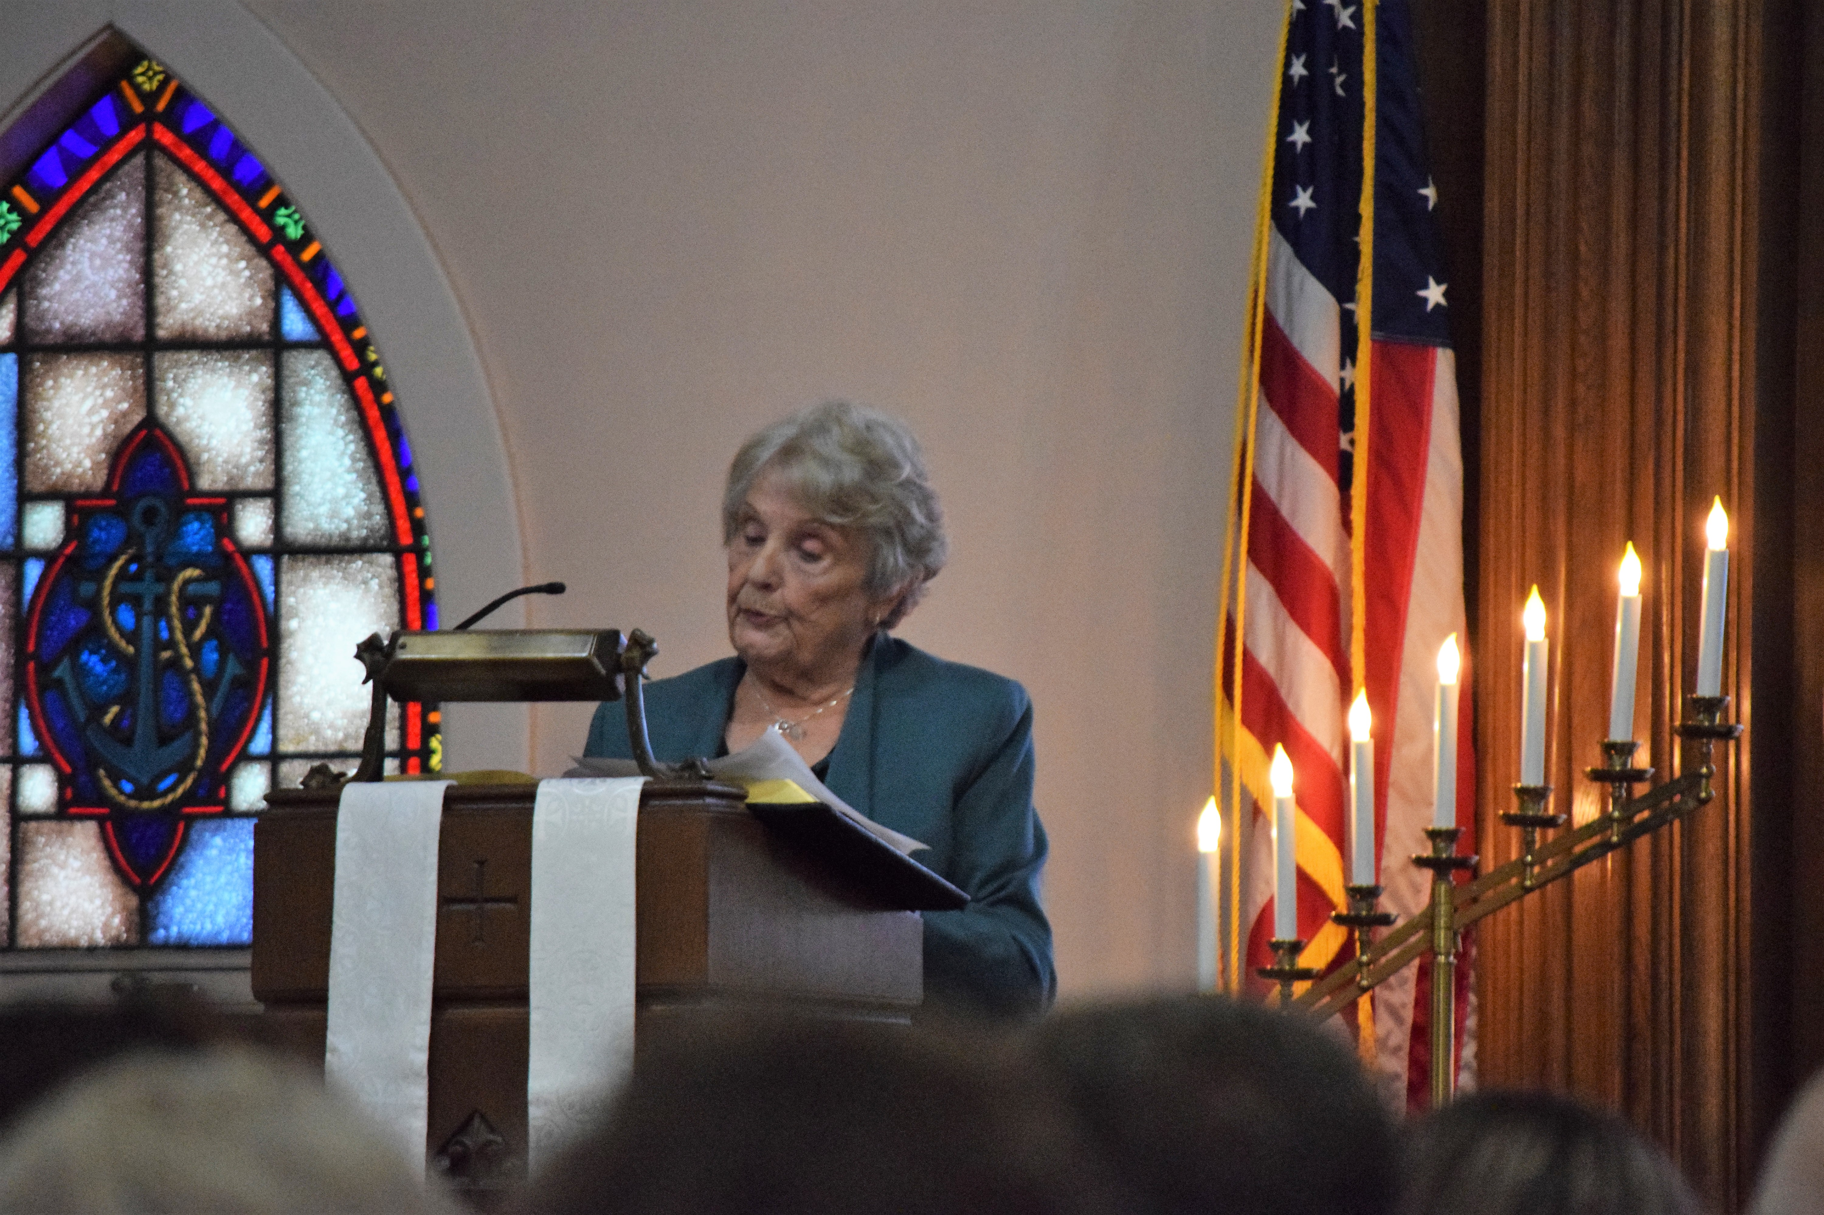
(Mrs. Judy Lange shares a message about the faith of our past forefathers and a charge to stay faithful to God in the future. Mrs. Lange was the wife of the late Reverend Clyde Lange who served here from 1969-1999).

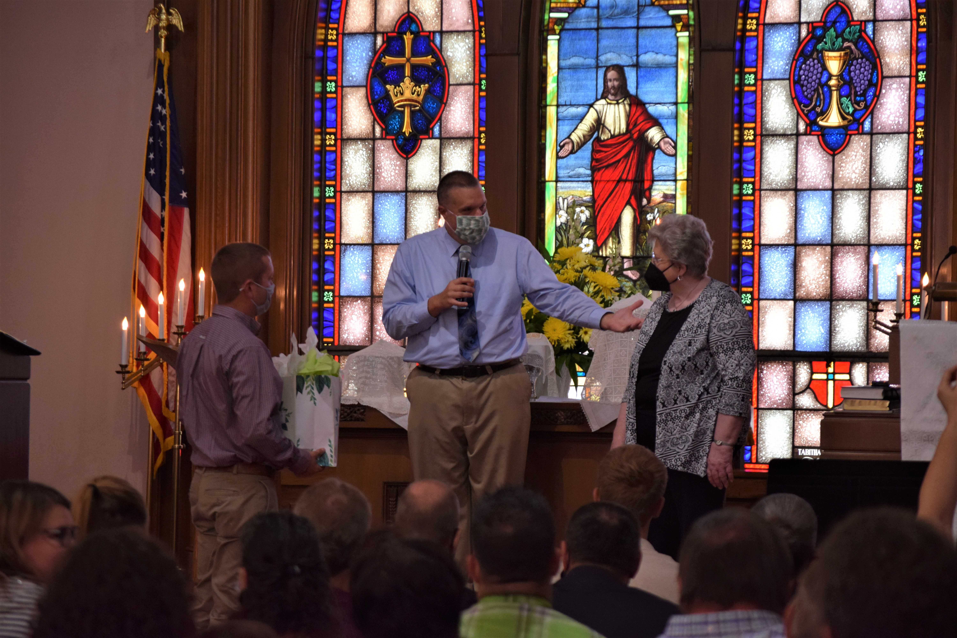
(Pastor Kyle and council president Max Toppen present choir director Ann Smith with a gift from St. Peter’s. Ann has served the congregation for 66 years).
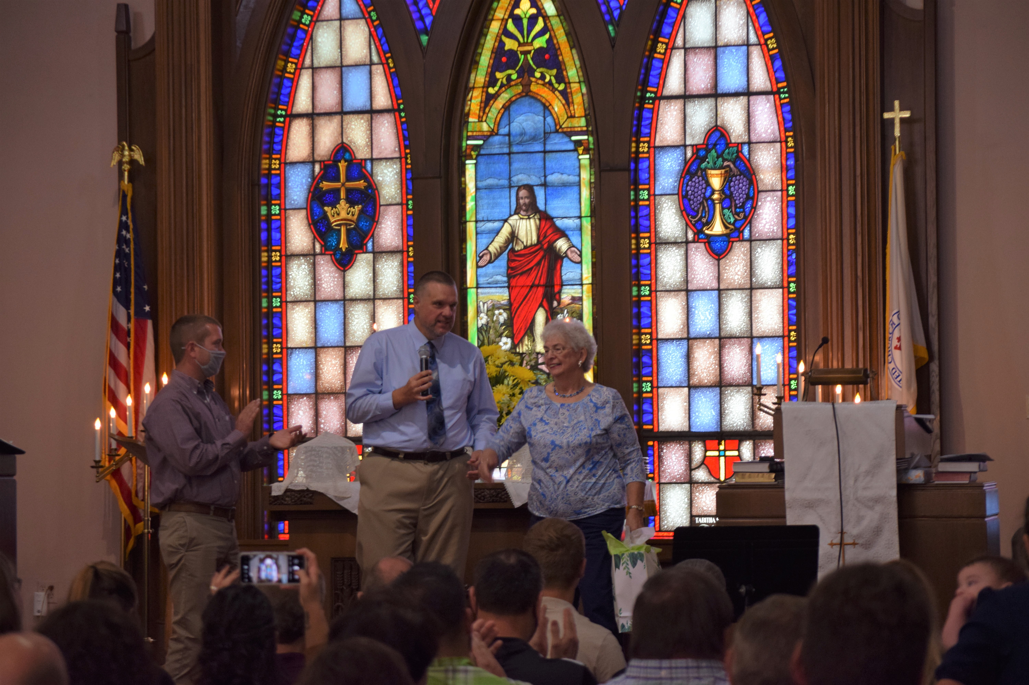
(Pastor Kyle and council president Max Toppen present organist Judy Schneider with a gift from St. Peter’s. Judy has served the congregation for over 62 years).
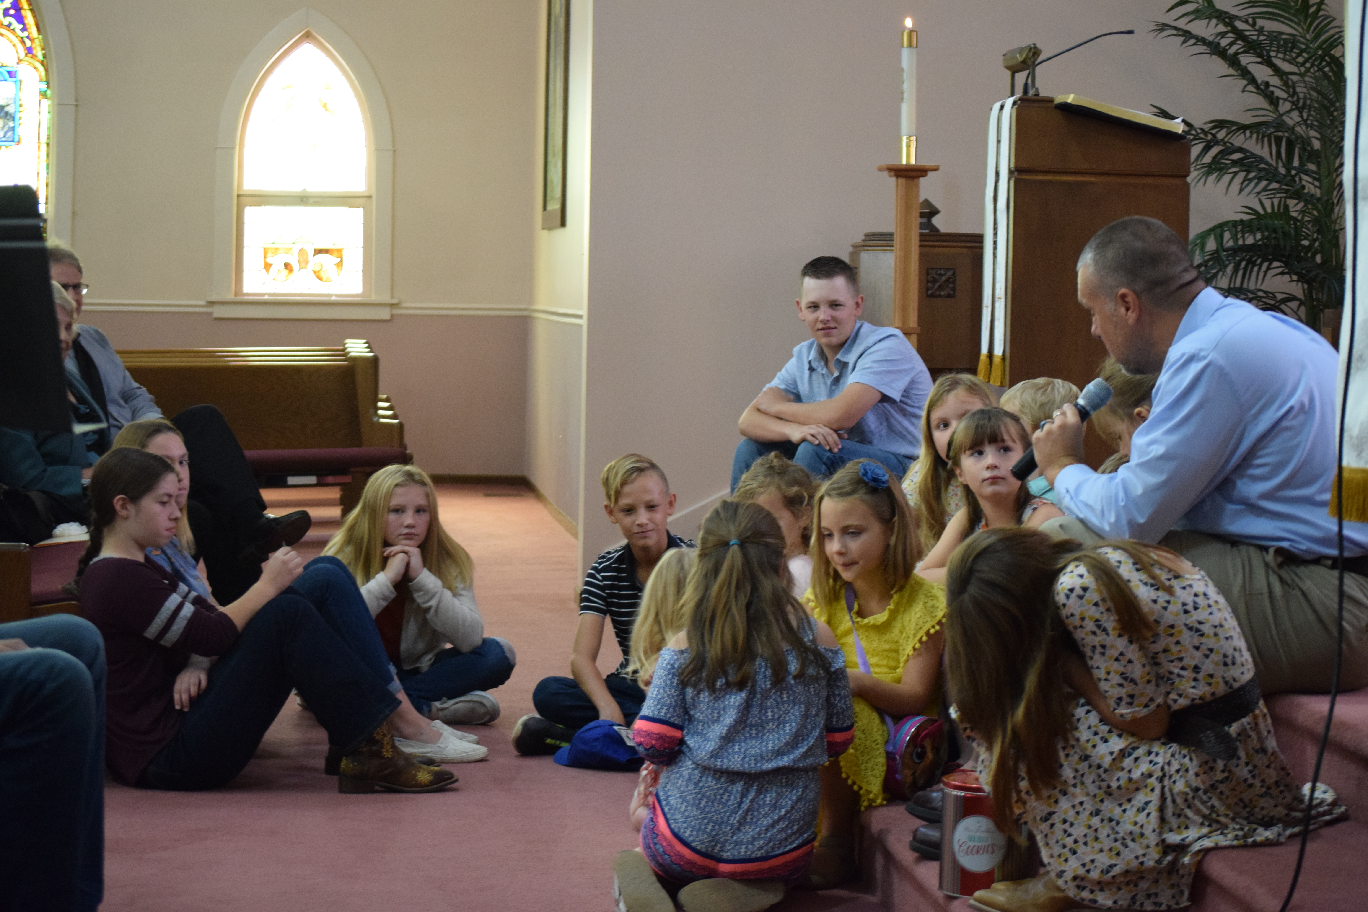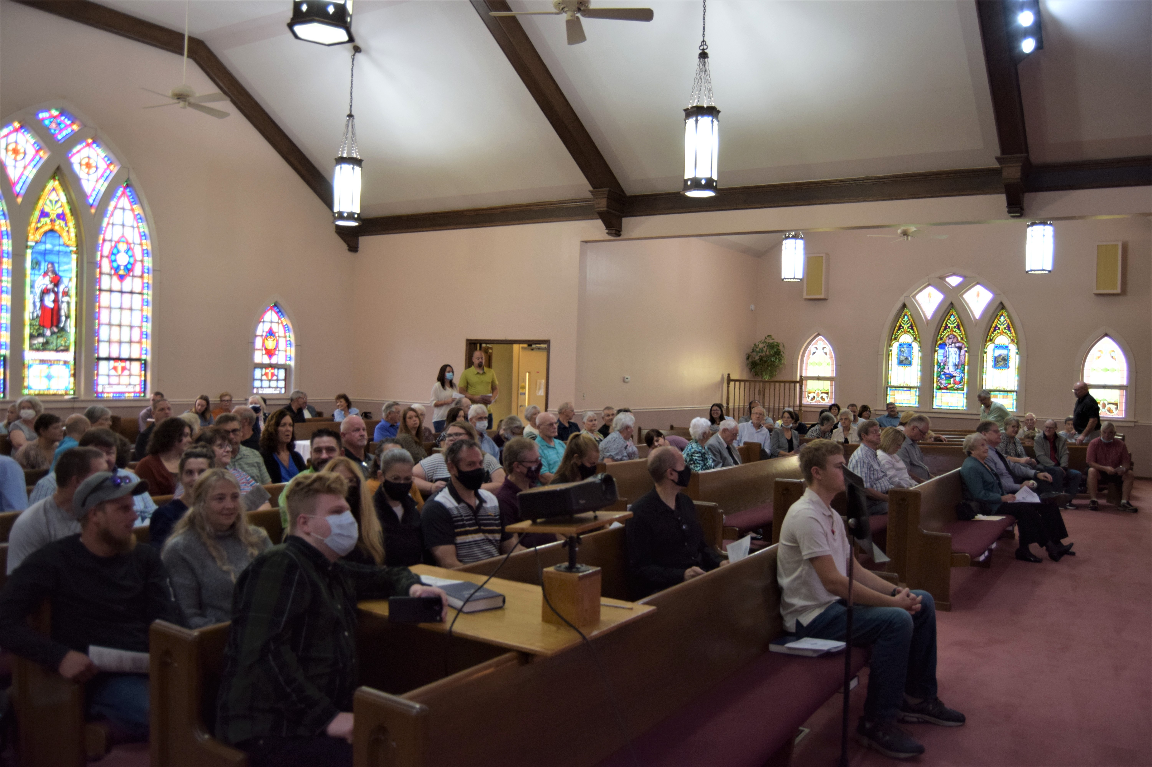
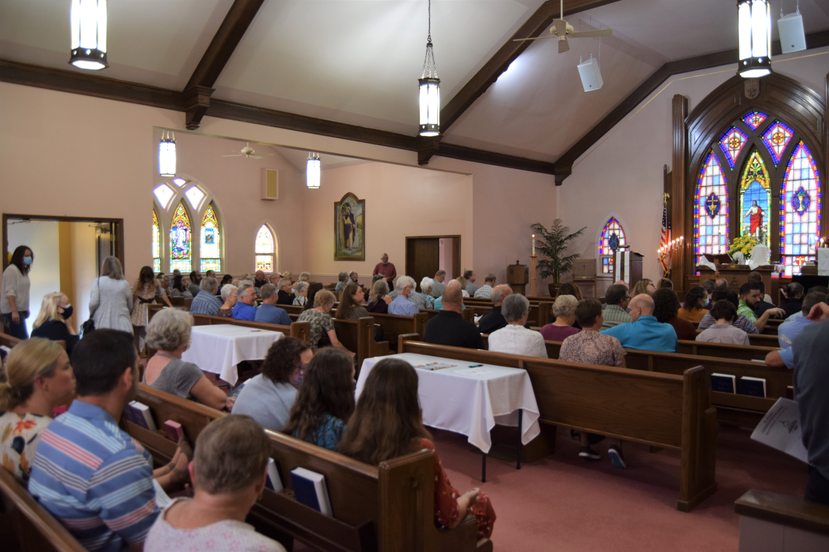
*Thank you Michelle Claussen for providing these photos.

MEMORIES OF OUR PAST

We received numerous replies to our mailing asking you to share your favorite memories of St. Peter’s. Here are some replies (we will share several over the next few months):

“Mr. Reaman ringing the bell when Sunday School was over, participating in the youth choir, serving at the Turkey Supper, teaching Sunday School, Christmas decorations and Christmas Eve services, and more.” – Kevin & Debbie Mussman

“I have a lifetime of memories. Music programs, festivals, directing choirs, being an organist and pianist, teaching Sunday School, leading worship, baptisms, confirmations, weddings, and funerals.” Ann Smith

“My wedding day (12/27/1958) at St. Peter’s and celebrating my late husband’s (Russell) 50th anniversary here in June of 2008.”
Norma Riley (currently lives in Virginia)

“I remember Ione Engleking as my Sunday School teacher at the age of three. One Sunday, I arrived with my shoes on the wrong feet. Very kindly, Ione insisted and lovingly “righted” my shoes!”
Shari Ohm

“I was baptized on April 5th, 1944, at home by the Reverend Wahl. I married Audrey at St. Peter’s on April 4th, 1964. I remember our three children and our first grandchild being baptized at St. Peter’s. I also remember the Sunday School addition and how it was an awesome undertaking in 1974.”
Daren Lehnert

“I remember my wedding day, the baptisms and confirmations of our children, and the calling of St. Peter’s first, and so far, only female pastor – Reverend Beverly Zell. I really enjoyed her time of ministry with our congregation.” Audrey Lehnert

NOVEMBER BIRTHDAY LIST

These birthdays are compiled from church membership records. Please call our attention to any omissions or corrections.

Ashlee Ekhoff 1 Hayden Lehnert 16 Greg Engleking 1 Marion Duensing 16
Bob Chesterfield 1 James Hamann 17
Kathy Sievers 2 Jayne Frahm 17
Jennie Hamann 3 Molly Markland 17
Karri Barrera 3 Dan Schneider 20
Norma Lehnert 3 Hadleigh Loitz 20
Bruce Heldt 5 Jeff Schneider 21
Kim Couwenhoven 5 Hailey Langlois 23
Kyle Timmons 8 Seth Hamann 23
Gordon Schneider 9 Brian Morris 24
Ken Bonifield 9 Jill Shafer 24
Kole Stadt 9 Jonathan Frahm 24
Jade Cadieux 10 Kennedy Marcotte 25
Roger Sturm 10 Gigi Schneider 28
Tyler Claussen 12 Nickolas Hamann 28
Kathy Ekhoff 14 Chris Claussen 29
Elaine Frahm 15 Joshua Lorenz 29
Gary Ekhoff 16 Krystal Frahm 29


Save the following dates for upcoming events and celebrations:

- November 6th –Turn back your clocks one hour.
- November 6th – Turkey Supper Day. We are still looking for volunteers to roast turkeys, donate desserts, and workers to help Friday and Saturday. Please contact the church office if interested.

November Calendar of Events (Tentative)

Date: | Time | Event
1st | 7:00 pm | 4-H Meeting
2nd | 7:00 pm | Christian Ed Meeting
3rd | 7:00 pm | Choir Practice
3rd | 8:00 pm | Dartball @ Matteson
5th | 8:00 am-? | Turkey Supper Food Prep
6th | 8:00 am-12:00 pm | Turkey Supper Food Prep
6th | 4:00pm-8:00 pm | Turkey Supper
7th | 10:30 am | Worship Service
8th | 7:00 pm | Man to Man Group
10th | 7:00 pm | Choir Practice
10th | 8:00 pm | Dartball v. Matteson
14th | 9:00 am | Sunday School
14th | 10:30 am | Worship Service
15th | 7:00 pm | Man to Man Group
17th | 7:00 pm | Choir Practice
17th | 8:00 pm | Dartball @ Peotone
21st | 9:00 am | Sunday School
21st | 10:30 am | Worship Service
21st | 11:30 am | Confirmation
21st | 1:30 pm | Dartball Mid-Season Tourn.@ Peotone
22nd | 7:00 pm | Man to Man Group
23rd | 7:00 pm | Council Meeting
28th | 9:00 am | Sunday School
28th | 10:30 am | Worship Service
29th | 7:00 pm | Man to Man Group

**Please note there is no Sunday School on November 7th.

stpetersgp@sbcglobal.net
Church Website: www.stpetersgp.org
Facebook: St. Peters UCC Grant Park
Church Office Hours: Monday–Thursday: 8AM – 11AM
Friday 8AM-12PM

Staff
Rev Kyle Timmons, Pastor
Jacquelyn Timmons, Office Administrator
Beverly Junker, Financial Secretary
Ann Smith, Senior Choir Director
Betty Wolfe, Youth Choir Director
Judy Schneider and Shari Ohm, Organists
Custodian
Jessica Bornemann & Kole Stadt, Youth Advisors
Neal Currier & Josh Hamann, Connect Leaders

2021 Church Council
Max Toppen, President
Brian McKinstry, Vice President
Heidi Frahm, Secretary
Michelle Claussen, Treasurer
Karen Ekhoff, Assistant Treasurer
Rhiannon Currier, Larry Voigt, Carrie Langlois, & David Lehnert



No Matter Who You Are or Where You Are on Life’s Journey, You Are Welcome Here

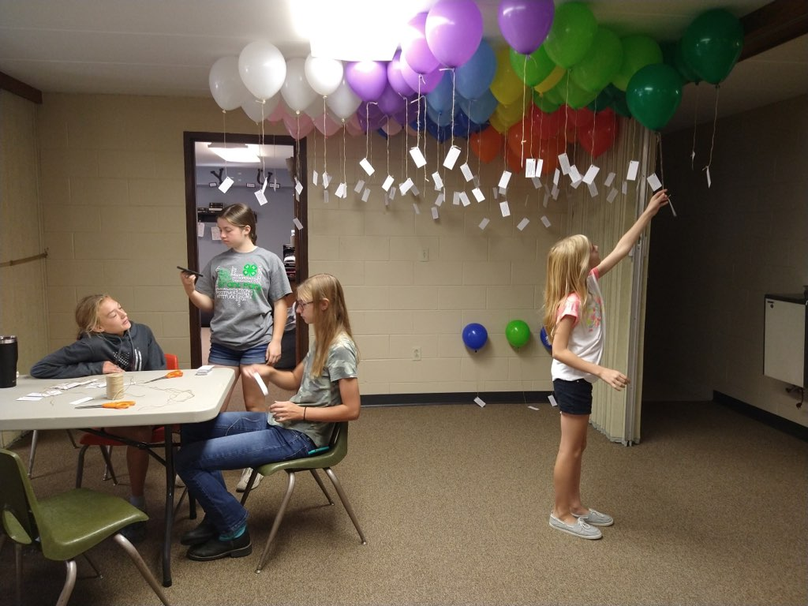

Rally Day was held on September 19th!
In addition to our Christian Education classes kicking off for the year, there was a presentation of Bibles to our children during the worship service, a balloon launch, and a bike-a-thon! Thank you to everyone who participated in this wonderful day!

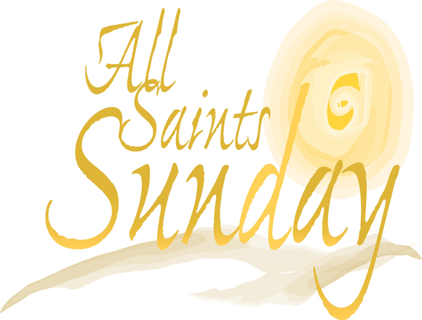
Totenfest Sunday (November 7th)

On Sunday, November 7th, we will celebrate the baptisms of any individuals who were baptized during the past 12 months.

Additionally, we will honor the lives of our loved ones who have gone on to their eternal home over the past 12 months.

If you lost a loved one between November of 2020 and October of 2021, please contact the church office with that person’s name, date of birth & death, and their relationship to you. These can be members or non-members of St. Peter’s UCC.

Job Opportunity – Church Custodian

We are looking for a new church custodian. If you are interested in learning more or would like to apply, please contact the church office or submit your resume.

Electronic (EFT) Giving

Are you interested in learning more about setting up your giving to St. Peter’s electronically? No more worrying about checks, offering envelopes, etc. Let Pastor Kyle know if you’d be interested in giving electronically and we’ll help you set it up. This is a GREAT way to make sure you are giving on a regular basis (even if you miss church due to illness, vacation, or weather).

Want to give, but forgot your cash/check?

In addition to EFT giving (see that announcement), there is another avenue that you can plug into your phone right now that is safe and protected. You can provide a credit card number or a bank account and set it up to give as frequently as you desire. Feel free to share the web address with others. https://tithe.ly/give?c=696160

Monthly Church Council Minutes

If you are interested in receiving a copy of the previous month’s council minutes, please contact the church office. An e-mail copy can be sent or we can supply a printed version.



The Missions’ Team at St. Peter’s would like to encourage everyone to be involved in serving Jesus. There are several ways you can actively and financially support local and church missions’ projects:

Beecher Food Pantry

The Beecher Food Pantry housed at St. Luke’s is in desperate need of our support. They are asking for donations of non-expired foods, hygiene products, and other items such as paper towels, detergent, kitchen soap, etc. on a regular basis. During November, the Pantry has asked for donations of Thanksgiving meal items that are non-perishable (i.e canned pumpkin, beans, corn, yams, macaroni and cheese boxes, etc.) If you are able to assist, we will be collecting these items Nov. 7th & 14th. Donations can be placed in the basket located in the entrance of the courtyard doors.

St. Peter’s UCC Blessing box

Don’t forget that we have a “Blessings’ Box” outside the courtyard church entrance. Feel free to donate to it as you can. *Several area youth often check it out to see if there are snacks and other families have relied on it over the years.

Mission’s Support Available

Are you, or someone you know, in need of financial assistance or support? Perhaps assistance in paying a bill? Food assistance? Help with a mission trip? If you’d like a request form, please email stpetersgp@sbcglobal.net, pastorkyletimmons@live.com , call us at (815) 465-6191, or check out our forms on our church website. Forms are to be submitted to the Mission’s Team.

Wait…Why am I getting this newsletter?

Many of you already receive the newsletter on a regular basis; however, for the majority of you, you probably haven’t received a mailed hard copy in quite some time.

If you are receiving this in the mail, we still consider you a part of our church family (whether active, non-active, living far away, or whatever your situation may be).

We want to let you know what has been going on at St. Peter’s and provide you with other information in regards to our church.

If you do not wish to receive the newsletters in the future, please let us know by emailing stpetersgp@sbcglobal.net or by leaving a message at the church (815) 465-6191.



You are the Body of Christ!
If you haven’t been to church in a while….
It’s okay – we are ready to have you back.

Christian Education Opportunities

Man-to-Man Group (Starting back up November 8th) – Faith, Fellowship, Food, and maybe Football. ALL men are welcome to join us on Mondays at 7 pm. We will discuss some books (don’t worry, you don’t have to buy/read the book if you don’t want to) written by Retired LTG William G. Boykin, former Commander of the U.S. Army Special Forces. There will be great fellowship, plenty of food, and if you want to stay and watch football with us that evening you may do so as well.

Virtual Bible Study with Pastor Kyle – Aren’t able to join us for a weekly Bible Study, but would still like to receive additional spiritual nourishment? Sign-up for a virtual Bible Study by Pastor Kyle. Email pastorkyletimmons@live.com if you’d like to receive a weekly reading schedule, discussion questions, and other spiritual emails.

How to Worship With Us Online

Facebook: Search for our church page by typing in St. Peters UCC Grant Park. Click on Videos and a list of our videos will appear. We will try to have each day’s service posted on or before our normal time that we would have had it (10:30am Sunday mornings, 7:00 pm evening, etc.)

YouTube: Go to www.youtube.com. In the search engine, type Pastor Kyle Timmons and search (you may need to scroll through to find), or the more direct way is to put in the following https://www.youtube.com/channel/UCV5nYMleHefrhcB4v4qHd4Q

Church Website: FYI – It’s fresh! It’s New! Check it out – new content will be added as we continue to develop the site, but now you can access the most recent services. Go to www.stpetersgrantpark.org or www.stpetersgp.org . On the top menu go to Media, Choose Sermons, and click the one you want to watch.
In Our Thoughts and Prayers:

Gary Ekhoff, Gene Sievers, Melissa Mort, Reverend Frank Hoss, Carter Fortin, Mason Beseke, Austin Delaney, Linda Havely, Taylor Cleary, Nancy Lewke, Ken Erickson, Dennis Balgemann, Joy Currier, Patrick Pahl, Cheyenne Jones, Donna Dorrough, the family of Ryan Ohm, and the family of Mildred Katz.

Contact Information for Members not able to attend
church on a regular basis

Louise Sievers Minnie Pfingsten Pauline Mitchell
Riverside Senior Life 703 N. East Street Bickford Sr. Living
85 E. Burns Rd. #39 Hudson, IL 61748 100 Jones Drive
Bourbonnais, IL 60914 Room 227
Bourbonnais, IL 60914
Rev Frank Hoss
601 Lutz Road
Bloomington, IL 61704

Greeters & Lay Reader Schedule

November 7th :
Greeters: Tom & Rita Morris
Lay Reader: Heidi Frahm

November 14th :
Greeters: Larry & Jan Voigt
Lay Reader: ?

November 21st :
Greeters: Larry & Gail Hamann
Lay Reader: ?

November 28th :
Greeter: Mike Reaman
Lay Reader: Karen Brunello

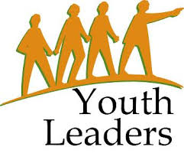
St. Peter’s is looking for someone (or more) to voluntarily lead our Fusion Youth Ministry as Kole Stadt and Jessica Bornemann have recently announced that they are stepping down.

Fusion is for students in grades 6-12. Leaders will be asked to plan and lead missions projects, monthly gatherings and events, or plan unique and fellowship style events for our youth. To learn more, please see Pastor Kyle.

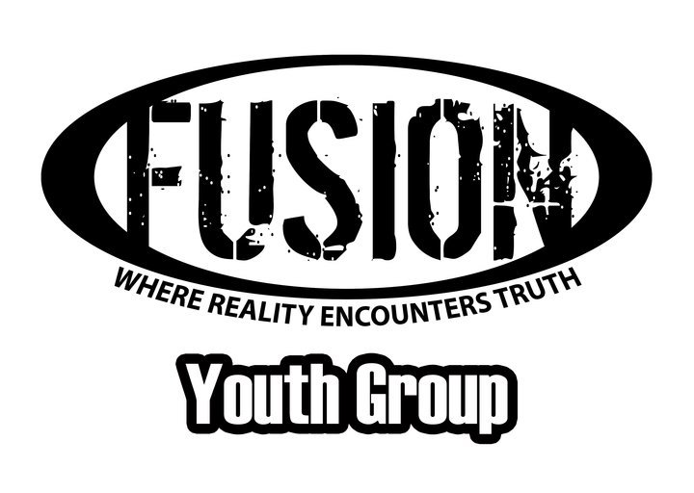
Students in Grades 6-12

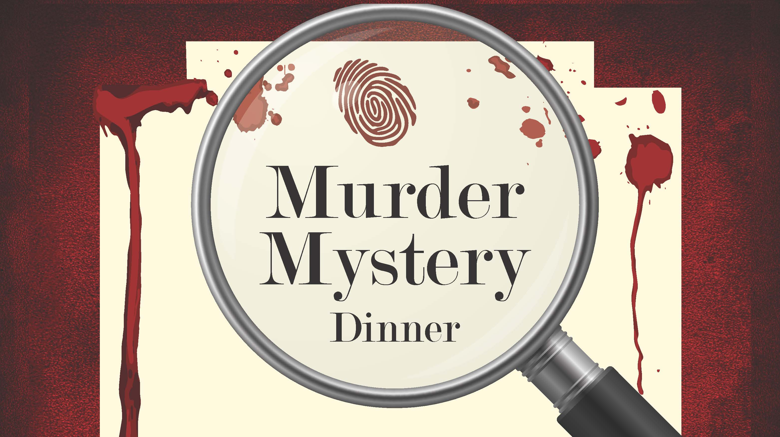
Students interested in being a part of a February Murder-Mystery Dinner should contact Pastor Kyle by the end of November and let him know you want to participate. More information will be provided at the end of the month.

2021-2022 Confirmation Class
Confirmation class will meet November 21st after church.

