St. Peter's
United Church of Christ

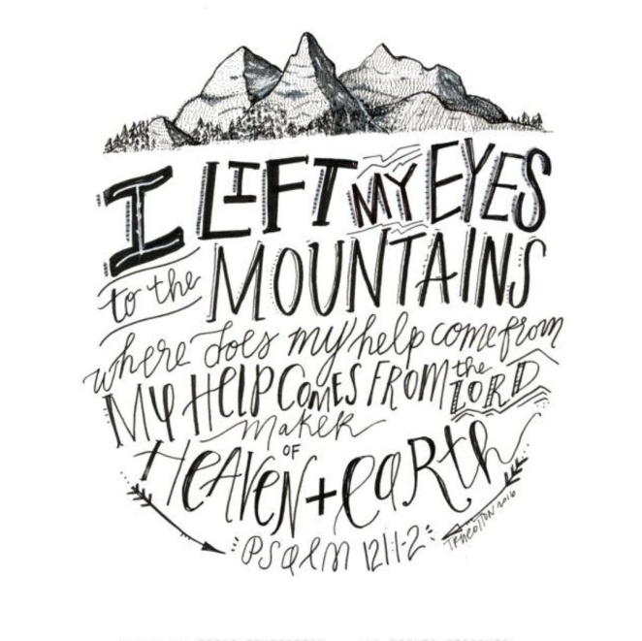

Sunday, October 11th, 2020
Celebrating 150 years of faithfulness to our community

St. Peter’s UCC (Grant Park)
310 North Meadow Street, PO Box 220
Grant Park, IL 60940
(815) 465-6191
www.stpetersgp.org (Email: stpetersgp@sbcglobal.net)
Find us on Facebook: St. Peters UCC Grant Park

Pastor: Kyle Timmons Office Manager: Marcia Langlois
Custodian: Peg McCraw Financial Secretary: Beverly Junker
Organist: Judy Schneider
Fusion (Youth) Advisors: Jessica Frahm & Kole Stadt

“My Help comes from the Lord, the Maker of heaven and earth.”
– Psalm 121:2

Pre-Service Music

Tolling of the Bell

Prelude “How Long Has it Been” (Lister) Judy Schneider

Welcome & Announcements

Concerns/Joys & Opening Pastoral Prayer

Opening Scripture Isaiah 2:1-5

*Worship in Song “Days of Elijah” Screen
“You Are Holy/Prince of Peace”

Stewardship Moment

Hymn “Children of the Heavenly Father”

Scripture Reading Psalm 121

Sermon “Every Which Way but Up” Pastor Kyle

*Closing Song “My Faith Looks up to Thee”

*Spoken Benediction

*Postlude “Psalm 100” (Wyrtzen) Judy Schneider

Scripture Reading: Isaiah 2:1-5

This is what Isaiah son of Amoz saw concerning Judah and Jerusalem:
² In the last days the mountain of the Lord’s temple will be established
as the highest of the mountains;
it will be exalted above the hills,
and all nations will stream to it.
³ Many peoples will come and say,
“Come, let us go up to the mountain of the Lord,
to the temple of the God of Jacob.
He will teach us his ways,
so that we may walk in his paths.”
The law will go out from Zion,
the word of the Lord from Jerusalem.
⁴ He will judge between the nations
and will settle disputes for many peoples.
They will beat their swords into plowshares
and their spears into pruning hooks.
Nation will not take up sword against nation,
nor will they train for war anymore.
⁵ Come, descendants of Jacob,
let us walk in the light of the Lord.

Scripture Reading: Psalm 121

I lift up my eyes to the mountains—
where does my help come from?
² My help comes from the Lord,
the Maker of heaven and earth.
³ He will not let your foot slip—
he who watches over you will not slumber;
⁴ indeed, he who watches over Israel
will neither slumber nor sleep.
⁵ The Lord watches over you—
the Lord is your shade at your right hand;
⁶ the sun will not harm you by day,
nor the moon by night.
⁷ The Lord will keep you from all harm—
he will watch over your life;
⁸ the Lord will watch over your coming and going
both now and forevermore.

Worship Music Team: Would you be interested in assisting in music on Sundays by leading our singing during our hymns and contemporary singing? See Pastor Kyle for more details.

Or,

Are you interested in singing? Playing an instrument? We’d love to have you share your musical gift with the congregation. Let Pastor Kyle, or the church office, know that you’d be interested in providing special music and for which Sunday. Looking forward to hearing your musical gift shared with us.
-------------------------------------------------------------------------------------------
This Week at St. Peter’s

Office Hours are 9 am – 1 pm (Tuesday – Friday) – If you have an emergency, or need to contact the Pastor, please call him at 567-249-5130.

Today:
Worship Team Mtg – 11:30 am

Sunday, Oct. 18th:
Christian Education – 9 am
Worship Service – 10:30 am
Confirmation – 11:30 – 2:00
------------------------------------------------------------------------------------------
Are you giving? A principle for Christian giving:

Our Lord Jesus expects and requires His followers to give. Jesus said, “when you give,” not “if you give” in Matthew 6:2. Therefore, Christian giving is vital and essential and not optional. Jesus desires His people to be faithful givers. Are you giving?

How can I give of my tithe and offerings:

Option 1 – Place your offering envelope or gift in the offering plate on Sunday mornings.

Option 2 – You can mail in your financial gifts to the church office. The address is St. Peter’s UCC, PO Box 231, Grant Park, IL 60940.

Option 3 – You can drop your financial gifts off to the church during office hours.

Option 4 – You can sign up to give automatically from your checking or savings account via an EFT automatic withdrawal – if you’d like a form to fill out, please contact the church office and we’ll help you set one up.

Option 5 – You can visit our church webpage for giving and make a secure donation at www.stpetersgp.org/give/ You can give just one time or set it up for reoccurring gifts as well.
--------------------------------------------------------------------------------------------
We at St. Peter’s are praying for:

Gary Ekhoff Gene Sievers Sherrie Hruby
Nancy Lewke Melissa Mort Carter Fortin
Austin Delaney Mason Beseke Rev. Frank Hoss
Delores Caton James Caton Linda Havely
The family of Helen Gamble The family of Mary Cirks

(If you wish for your name to be taken off this list, or would like to be added to the list, please let Pastor Kyle or the church office know. Thanks in advance).
-----------------------------------------------------------------------------------------------
We also remember our shut-ins:

Mildred Katz Pauline Mitchell Minnie Pfingsten Louise Sievers

Days of Elijah
CCLI Streaming License #20454163 – Written by Robin Mark

These are the days of Elijah,
Declaring the word of the Lord
And these are the days of
Your servant Moses,
Righteousness being restored.
And though these are days
of great trial, of famine and darkness and sword,
Still, we are the
voice in the desert crying
"Prepare ye the way of the Lord!"

(Chorus)
Behold He comes riding on the clouds, Shining like the sun
at the trumpet call,
Lift your voice, it's the year of jubilee, and out of Zion’s hill
salvation comes.

And these are the days of Ezekiel,
The dry bones becoming as flesh,
And these are the days of
Your servant David,
Rebuilding a temple of praise.
These are the days of the harvest,
The fields are as white
in Your world,
And we are the labourers
in Your vineyard,
Declaring the word of the Lord!

(Chorus)

There's no God like Jehovah.
(x’s 16)

(Chorus – Repeated)

You are Holy (Prince of Peace)
CCLI Streaming License #20454163 – Michael W. Smith

*= Women Echo

You are holy ( * women echo)
You are mighty (*)
You are worthy (*)
Worthy of praise (*)

I will follow (*)
I will listen (*)
I will love you (*)
All of my days (*)

(MEN)
I will sing to
And worship
The Kingdom is worthy
I will love and adore Him
And I will bow down before Him
And I will sing to and worship the Kingdom is worthy
And I will love and adore
And I will bow down before Him
You're my prince of peace
And I will live my life for You

(WOMEN)
You are Lord of Lords!
You are King of kings!
You are Mighty God!
Lord of everything!
You’re Emmanuel!
You’re the Great I AM!
You’re the Prince of Peace
Who is the lamb
You’re the Living God!
You’re my Saving Grace!
You will reign forever
You are Ancient of Days
You are Alpha, Omega,
Beginning, and End
You’re my Savior, Messiah
Redeemer and Friend.
You’re my Prince of Peace
And I will live my life for You!

