St. Peter's
United Church of Christ

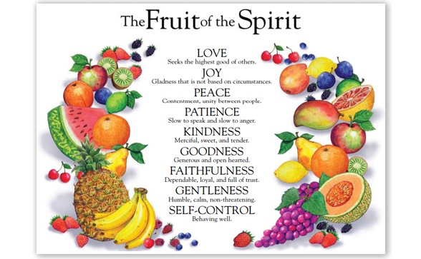

Sunday, September 6th, 2020

St. Peter’s UCC (Grant Park)
310 North Meadow Street, PO Box 220
Grant Park, IL 60940
(815) 465-6191
www.stpetersgp.org (Email: stpetersgp@sbcglobal.net)
Find us on Facebook: St. Peters UCC Grant Park

Pastor: Kyle Timmons Office Manager: Marcia Langlois
Custodian: Peg McCraw Financial Secretary: Beverly Junker
Fusion (Youth) Co-Advisors: Jessica Frahm & Kole Stadt

“The fruit of the Spirit is love, joy, peace, patience, kindness, goodness, gentleness, faithfulness and self-control.” – Galatians 5:22-23

Pre-Service Music “Love Lifted Me” (Gaither Vocal Band)

Welcome and Announcements

Prelude “It Makes Me Want to Go” (Tribute Quartet)

*Call to Worship

Pastor: The whole law is summed up in a single commandment,
People: “Love your neighbor as yourself.”
Pastor: Live by the Spirit;
People: For we are led by the Spirit into the world.
Pastor: We belong to Jesus;
People: We do not belong to this world.
Pastor: Let us love and serve one another, as led by the Spirit.
People: May we worship God, through the guidance of the Holy
Spirit, and the love of Jesus Christ.

*Unison Prayer of Invocation
God, You call us to go where Christ leads. Turn us from the ways of the world; guide us to fullness of joy in the Spirit, where bodies and souls rest secure; and grant us strength to follow the way of the cross, which frees us to love one another for the sake of all creation. Amen.

*Song “Come Thou Fount”
“10,000 Reasons (Remix)”

Pastoral Prayer (Concerns & Joys)

Scripture Matthew 22:34-40

Sermon “Rotten or Ripe: Love” Pastor Kyle
The Lord’s Supper
Invitation to the Table
Prayer of Confession & The Lord’s Prayer
“Remembrance (Communion Song)” (Redman)
Words of Institution
Prayer of Consecration
Partaking of the Meal
Prayer of Thanksgiving

Closing Song “Jesus, Keep Me Near the Cross”

Benediction
May the grace of God free you from the bondage of the law.
May the grace of God free you for life in the Spirit.
May the grace of God bear in you joy, peace, patience, kindness, goodness, faithfulness, gentleness, and self-control.
May the grace of God convince you, in every situation, to love.
Go now to love others, even as Christ loves you.
(UM Worship & Song Worship Resource, #176, adapted)

--------------------------------------------------------------------------------------------
Scripture: Matthew 22:34-40
Hearing that Jesus had silenced the Sadducees, the Pharisees got together. One of them, an expert in the law, tested him with this question: “Teacher, which is the greatest commandment in the Law?”
Jesus replied: “ ‘Love the Lord your God with all your heart and with all your soul and with all your mind.’ This is the first and greatest commandment. And the second is like it: ‘Love your neighbor as yourself.’ All the Law and the Prophets hang on these two commandments.”

Come Thou Fount
–Words by Robert Robinson, Music/Vocals by Nathan Drake
Performed by Reawaken Hymns: Copyright License 20454170

Come thou Fount of every blessing,
Tune my heart to sing Thy grace.
Streams of mercy, never ceasing,
Call for songs of loudest praise.
Teach me some melodious sonnet,
Sung by flaming tongues above.
Praise His name, I'm fixed upon it,
Name of God’s redeeming love.

Here I raise my Ebenezer;
Here by Thy great help I’ve come;
And I hope, by Thy good pleasure,
Safely to arrive at home.
Jesus sought me when a stranger,
Wandering from the fold of God;
He, to rescue me from danger,
Interposed His precious blood;

Oh to grace how great a debtor,
Daily I'm constrained to be.
Let Thy goodness, like a fetter,
Bind my wandering heart to Thee.
Prone to wander, Lord I feel it,
Prone to leave the God I love.
Here's my heart Lord, take and seal it,
Seal it for Thy courts above.

Jesus, Keep Me Near the Cross
Words by Fanny Crosby, Music by William Howard Doane
Copyright License 20454170, Streaming License #20454163

Jesus, keep me near the cross,
There a precious fountain,
Free to all, a healing stream,
Flows from Calvary’s mountain.

(Chorus) In the cross, in the cross
Be my glory ever,
Till my raptured soul shall find
Rest beyond the river.

Near the cross, a trembling soul,
Love and mercy found me;
There the Bright and Morning Star
Sheds its beams around me.
(Chorus)

Near the cross! O Lamb of God,
Bring its scenes before me;
Help me walk from day to day
With its shadows o’er me.

(Chorus)

Near the cross I’ll watch and wait,
Hoping, trusting ever,
Till I reach the golden strand,
Just beyond the river.
(Chorus)

10,000 Reasons (Remix)
Songwriters: David T. Clydesdale/Steve Amerson
Copyright License 20454170, Streaming License #20454163

Bless the Lord, O My Soul, O My Soul
Worship His Holy Name
Sing like never before, O My Soul.
Worship You’re Holy Name.

The sun comes up, it’s a new day dawning
Its time to sing Your song again
Whatever may pass and whatever lies before me.
Let me be singing when the evening comes.

Bless the Lord, O My Soul, O My Soul
Worship His Holy Name
Sing like never before, O My Soul.
Worship You’re Holy Name. (Repeat – x’s 2)

SERMON NOTES

