St. Peter's
United Church of Christ

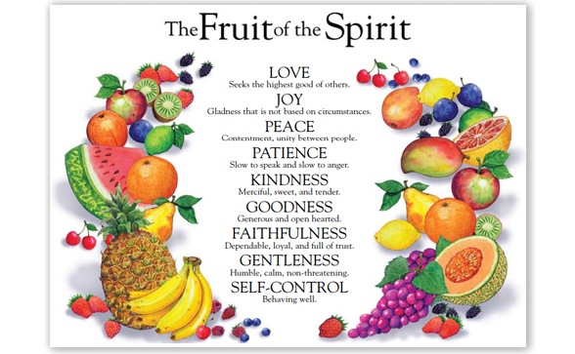

Sunday, August 30th, 2020

St. Peter’s UCC (Grant Park)
310 North Meadow Street, PO Box 220
Grant Park, IL 60940
(815) 465-6191
www.stpetersgp.org (Email: stpetersgp@sbcglobal.net)
Find us on Facebook: St. Peters UCC Grant Park

Pastor: Kyle Timmons Office Manager: Marcia Langlois
Custodian: Peg McCraw Financial Secretary: Beverly Junker
Fusion (Youth) Co-Advisors: Jessica Frahm & Kole Stadt

“The fruit of the Spirit is love, joy, peace, patience, kindness, goodness, gentleness, faithfulness and self-control.” – Galatians 5:22-23

Pre-Service Music “Every Praise” (by Hezekiah Walker)

Welcome and Announcements

Prelude “Sing for Joy” (by Don Moen)

*Call to Worship
“Make a joyful noise to the Lord, all the earth; break forth into joyous song and sing praises. Sing praises to the Lord with the lyre, with the lyre and the sound of melody. With trumpets and the sound of the horn make a joyful noise before the King, the Lord. Let the sea roar, and all that fills it; the world and those who live in it. Let the floods clap their hands; let the hills sing together for joy at the presence of the Lord, for He is coming to judge the earth. He will judge the world with righteousness, and the peoples with equity.” (Psalm 98)

Pastor: Here we are Lord!
People: We come into your house with praises on our lips, for
Your faithfulness is never ending.
Pastor: We give thanks for your mercy.
People: As we seek Your joy, we thank You for creating us and
giving us life and breath today
People: We give You praise, in the name of our Savior, Jesus
Christ, and the Holy Spirit whose presence is here with us, uniting us as Your people. Fill us with Your joy and peace today. Amen.

*Prayer of Invocation

*Song “Joyful, Joyful We Adore Thee”

Pastoral Prayer (Concerns & Joys)

Song “Standing on the Promises”

Scripture I Peter 1:3-9

Sermon “Rotten or Ripe: Joy” Pastor Kyle

Closing Song “Sing for Joy”

Benediction

Scripture: I Peter 1:3-9
³ Praise be to the God and Father of our Lord Jesus Christ! In his great mercy he has given us new birth into a living hope through the resurrection of Jesus Christ from the dead, ⁴ and into an inheritance that can never perish, spoil or fade. This inheritance is kept in heaven for you, ⁵ who through faith are shielded by God’s power until the coming of the salvation that is ready to be revealed in the last time. ⁶ In all this you greatly rejoice, though now for a little while you may have had to suffer grief in all kinds of trials. ⁷ These have come so that the proven genuineness of your faith—of greater worth than gold, which perishes even though refined by fire—may result in praise, glory and honor when Jesus Christ is revealed. ⁸ Though you have not seen him, you love him; and even though you do not see him now, you believe in him and are filled with an inexpressible and glorious joy, ⁹ for you are receiving the end result of your faith, the salvation of your souls.

Joyful, Joyful
–Words by Van Dyke, Music by Beethoven
Performed by Tommy Walker: Copyright License 20454170

Joyful, joyful, we adore Thee God of glory, Lord of love
Hearts unfold like flowers before Thee Hail Thee as the sun above
Melt the clouds of sin and sadness, drive the dark of doubt away
Giver of immortal gladness fill us with the light of day.

All Thy works with joy surround Thee Earth and heaven reflect Thy ways
Stars and angels sing around Thee, center of unbroken praise
Field and forest, vale and mountain, blossoming meadow, flashing sea
Chanting bird and flowing fountain, call us to rejoice in Thee

You bring us joy, joy, joy – We adore Thee (Repeat)

Thou art giving and forgiving, ever blessing, ever blest.
Wellspring of the joy of living, ocean depth of happy rest
Thou the Father, Christ our Brother, all who live in love are Thine
Teach us how to love each other, lift us to the joy divine.

Mortals, join the mighty chorus which the morning stars began
Father love is reigning over us, brother love binds man to man.
Ever singing, march we onward, victors in the midst of strife.
Joyful music lifts us sunward, in the triumph song of life.

You bring us joy, joy, joy – We adore Thee (repeat 3 x’s)
We adore Thee, We adore Thee (repeat)

Standing on the Promises
Author: Russell Kelso Carter
Copyright License 20454170, Streaming License #20454163

Standing on the promises of Christ my King
Through eternal ages let his praises ring
Glory in the highest, I will shout and sing
(Chorus) Standing on the promises of God
Standing, standing
Standing on the promises of God my Savior
Standing, standing
I'm standing on the promises of God

Standing on the promises, I cannot fall
Listening every moment to the Spirit's call
Resting in my Savior as my all in all
(Chorus)

Sing for Joy
Songwriters: David T. Clydesdale/Steve Amerson
Copyright License 20454170, Streaming License #20454163

If we call to Him, He will answer us
If we run to Him, He will run to us
If we lift our hands, He will lift us up
Come now praise His name, all you saints of God

(Chorus) Oh, sing for joy to God our strength
Oh, sing for joy to God our strength, our strength

Draw near to Him, He is here with us
Give Him your love, He's in love with us
He will heal our hearts, He will cleanse our hands
If we rend our hearts He will heal our land (Yes He will)

(Chorus)

If we call to Him, He will answer us
If we run to Him, He will run to us
If we lift our hands, He will lift us up
Come now praise his name, all you saints of God
Draw near to Him, He is here with us
Give Him your love, He's in love with us
He will heal our hearts, He will cleanse our hands
If we rend our hearts He will heal our land (Yes He will)
Oh, sing (sing) for joy to God our strength (Repeat 2 x’s)
Oh, sing (sing) for joy to God our strength (Come on sing for joy)
Oh, sing (sing) for joy to God our strength (Repeat)
(Come on) Sing (sing) for joy to God our strength
Oh, sing (sing) for joy to God our strength, our strength

