St. Peter's
United Church of Christ

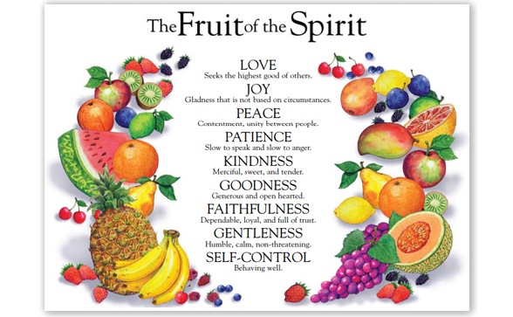

Sunday, August 23th, 2020

St. Peter’s UCC (Grant Park)
310 North Meadow Street, PO Box 220
Grant Park, IL 60940
(815) 465-6191
www.stpetersgp.org (Email: stpetersgp@sbcglobal.net)
Find us on Facebook: St. Peters UCC Grant Park

Pastor: Kyle Timmons Office Manager: Marcia Langlois
Custodian: Peg McCraw Financial Secretary: Beverly Junker
Fusion (Youth) Co-Advisors: Jessica Frahm & Kole Stadt

“The fruit of the Spirit is love, joy, peace, patience, kindness, goodness, gentleness, faithfulness and self-control.” – Galatians 5:22-23

Welcome and Announcements

Prelude “Whispers of My Father – Gentleness”

*Call to Worship
Pastor: Our good works are done with gentleness.
People: Bitterness only leads to anguish.
Pastor; God seeks peace and hope for all His people.
People: If our hearts are filled with anger, we reject His mercy.
Pastor: Open our hearts, O Lord, and help us to listen.
People: Open our lives, O Lord, prepare us to serve. Amen.

*Prayer
O God, You do work in mysterious ways! We see this in the movement of Your Spirit, holy and gentle. May Your Spirit work powerfully and gently in us so that our actions are likewise. Guide us to be more attentive and responsive to the Spirit’s leading. Reside with us this hour as we worship You in all we sing, hear, and learn. Amen.

*Song “All Creatures of Our God and King”

Pastoral Prayer (Concerns & Joys)

Song “Spirit, Spirit of Gentleness” Insert

Scripture I Timothy 6:11-21

Sermon “Rotten or Ripe: Gentleness” Pastor Kyle

Closing Song “My Hope is Built”

Benediction

My Hope is Built
–Written by Edward Mote, 1834: Copyright License 20454170

My hope is built on nothing less
than Jesus' blood and righteousness.
I dare not trust the sweetest frame,
but wholly lean on Jesus' name.

Refrain: On Christ the solid rock I stand,
all other ground is sinking sand;
all other ground is sinking sand.

When Darkness veils his lovely face,
I rest on his unchanging grace.
In every high and stormy gale,
my anchor holds within the veil. (Refrain)

His oath, his covenant, his blood
supports me in the whelming flood.
When all around my soul gives way,
he then is all my hope and stay. (Refrain)

When he shall come with trumpet sound,
O may I then in him be found!
Dressed in his righteousness alone,
faultless to stand before the throne! (Refrain)

All Creatures of Our God and King
Words and Music: William Henry Draper/St. Francis of Assisi
Copyright License 20454170, Streaming License #20454163

All creatures of our God and King,
lift up your voice and with us sing
O praise Him, alleluia!
Thou burning sun with golden beam,
thou silver moon with softer gleam,
O praise him, O praise him,
alleluia, alleluia, alleluia!

Let all things their Creator bless,
and worship him in humbleness,
O praise him, alleluia!
Praise, praise the Father,
praise the Son,
and praise the Spirit, three in one,
O praise him, O praise him,
alleluia, alleluia, alleluia!

All the Redeemed washed by
His blood
Come and rejoice in His great love
O praise him, alleluia
Christ has defeated every sin
Cast all your burdens now on Him
O praise him, O praise him,
Alleluia, alleluia, alleluia!

He shall return in power to reign
Heaven and earth will join to say
O praise him, alleluia
Then who shall fall on bended knee?
All creatures of our God and King
O praise him! O praise Him!
Alleluia, Alleluia, O praise Him
O praise Him, alleluia, alleluia, alleluia

Praise God from whom all blessings flow!
Praise Him all creatures here below!
Praise Him above ye heavenly host!
Praise Father, Son, and Holy Ghost!

Scripture: I Timothy 6:11-21
¹¹ But you, man of God, flee from all this, and pursue righteousness, godliness, faith, love, endurance and gentleness. ¹² Fight the good fight of the faith. Take hold of the eternal life to which you were called when you made your good confession in the presence of many witnesses. ¹³ In the sight of God, who gives life to everything, and of Christ Jesus, who while testifying before Pontius Pilate made the good confession, I charge you ¹⁴ to keep this command without spot or blame until the appearing of our Lord Jesus Christ, ¹⁵ which God will bring about in his own time—God, the blessed and only Ruler, the King of kings and Lord of lords, ¹⁶ who alone is immortal and who lives in unapproachable light, whom no one has seen or can see. To him be honor and might forever. Amen.
¹⁷ Command those who are rich in this present world not to be arrogant nor to put their hope in wealth, which is so uncertain, but to put their hope in God, who richly provides us with everything for our enjoyment. ¹⁸ Command them to do good, to be rich in good deeds, and to be generous and willing to share. ¹⁹ In this way they will lay up treasure for themselves as a firm foundation for the coming age, so that they may take hold of the life that is truly life.
²⁰ Timothy, guard what has been entrusted to your care. Turn away from godless chatter and the opposing ideas of what is falsely called knowledge, ²¹ which some have professed and in so doing have departed from the faith.
Grace be with you all.

