St. Peter's
United Church of Christ

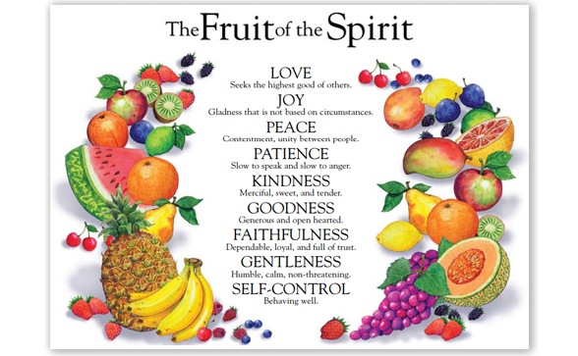

Sunday, August 16th, 2020

St. Peter’s UCC (Grant Park)
310 North Meadow Street, PO Box 220
Grant Park, IL 60940
(815) 465-6191
www.stpetersgp.org (Email: stpetersgp@sbcglobal.net)
Find us on Facebook: St. Peters UCC Grant Park

Pastor: Kyle Timmons Office Manager: Marcia Langlois
Custodian: Peg McCraw Financial Secretary: Beverly Junker
Today’s Organist: Judy Schneider
Fusion (Youth) Co-Advisors: Jessica Frahm & Kole Stadt

“The fruit of the Spirit is love, joy, peace, patience, kindness, goodness, gentleness, faithfulness and self-control.” – Galatians 5:22-23

Welcome and Announcements

Prelude “Be Thou My Vision” (Pacheco)

*Call to Worship
Pastor: In the midst of our mistakes and failures,
People: We stand in God’s amazing grace.
Pastor: In the midst of our struggles,
People: We boast in our hope through Jesus Christ.
Pastor: In the midst of our pain and suffering,
People: We claim the endurance given by the Holy Spirit.
Pastor: In each and every part of our lives,
People: The love our Creator has been poured into our hearts.
All: Let us be open to this love as we worship together.

*Prayer (pray silently) (written by Dick Woodward)
God, teach us what it means to have faith in silence. When we face trials that are beyond our understanding, help us to find peace. Help me be joyful in hope, patient in affliction, and faithful in prayer. You set all things in accordance to your time. Remind us to wait patiently, and find peace in your plan. Amen.

*Song “Come Thou Fount”

Pastoral Prayer (Concerns & Joys)

Children’s Moment

Scripture Hebrews 6

Sermon “Rotten or Ripe: Patience” Pastor Kyle

Closing Song “10,000 Reasons”

Benediction

Be Thou My Vision
Words and Music: Audrey Assad Copyright License 20454170

Be Thou my Vision, O Lord of my heart
Naught be all else to me, save that Thou art
Thou my best Thought, by day or by night
Waking or sleeping, Thy presence my light

Be Thou my Wisdom, and Thou my true Word
I ever with Thee and Thou with me, Lord
Thou my great Father, I Thy true son
Thou in me dwelling, and I with Thee one

Riches I heed not, nor man's empty praise
Thou mine Inheritance, now and always
Thou and Thou only, first in my heart
High King of Heaven, my Treasure Thou art

High King of Heaven, my victory won
May I reach Heaven's joys, O bright Heav'n's Sun
Heart of my own heart, whate'er befall
Still be my Vision, O Ruler of all

10,000 Reasons
–Written by Matt Redman: Copyright License 20454170

Bless the Lord O my soul, O my soul
Worship His Holy name
Sing like never before, O my soul
I’ll worship Your Holy name

The sun comes up, it’s a new day dawning
It’s time to sing Your song again
Whatever may pass and whatever lies before me
Let me be singing when the evening comes.

You’re rich in love and You’re slow to anger
Your name is great and Your heart is kind
For all Your goodness I will keep on singing
Ten thousand reasons for my heart to find

And on that day when my strength is failing
The end draws near and my time has come
Still my soul will sing Your praise unending
Ten thousand years and then forevermore

Scripture: Hebrews 6
6 Therefore let us move beyond the elementary teachings about Christ and be taken forward to maturity, not laying again the foundation of repentance from acts that lead to death,^{[a]} and of faith in God, ² instruction about cleansing rites,^{[b]} the laying on of hands, the resurrection of the dead, and eternal judgment. ³ And God permitting, we will do so.
⁴ It is impossible for those who have once been enlightened, who have tasted the heavenly gift, who have shared in the Holy Spirit, ⁵ who have tasted the goodness of the word of God and the powers of the coming age ⁶ and who have fallen^{[c]} away, to be brought back to repentance. To their loss they are crucifying the Son of God all over again and subjecting him to public disgrace. ⁷ Land that drinks in the rain often falling on it and that produces a crop useful to those for whom it is farmed receives the blessing of God. ⁸ But land that produces thorns and thistles is worthless and is in danger of being cursed. In the end it will be burned.
⁹ Even though we speak like this, dear friends, we are convinced of better things in your case—the things that have to do with salvation. ¹⁰ God is not unjust; he will not forget your work and the love you have shown him as you have helped his people and continue to help them. ¹¹ We want each of you to show this same diligence to the very end, so that what you hope for may be fully realized. ¹² We do not want you to become lazy, but to imitate those who through faith and patience inherit what has been promised.
¹³ When God made his promise to Abraham, since there was no one greater for him to swear by, he swore by himself, ¹⁴ saying, “I will surely bless you and give you many descendants.”¹⁵ And so after waiting patiently, Abraham received what was promised.
¹⁶ People swear by someone greater than themselves, and the oath confirms what is said and puts an end to all argument. ¹⁷ Because God wanted to make the unchanging nature of his purpose very clear to the heirs of what was promised, he confirmed it with an oath. ¹⁸ God did this so that, by two unchangeable things in which it is impossible for God to lie, we who have fled to take hold of the hope set before us may be greatly encouraged. ¹⁹ We have this hope as an anchor for the soul, firm and secure. It enters the inner sanctuary behind the curtain, ²⁰ where our forerunner, Jesus, has entered on our behalf. He has become a high priest forever, in the order of Melchizedek.

