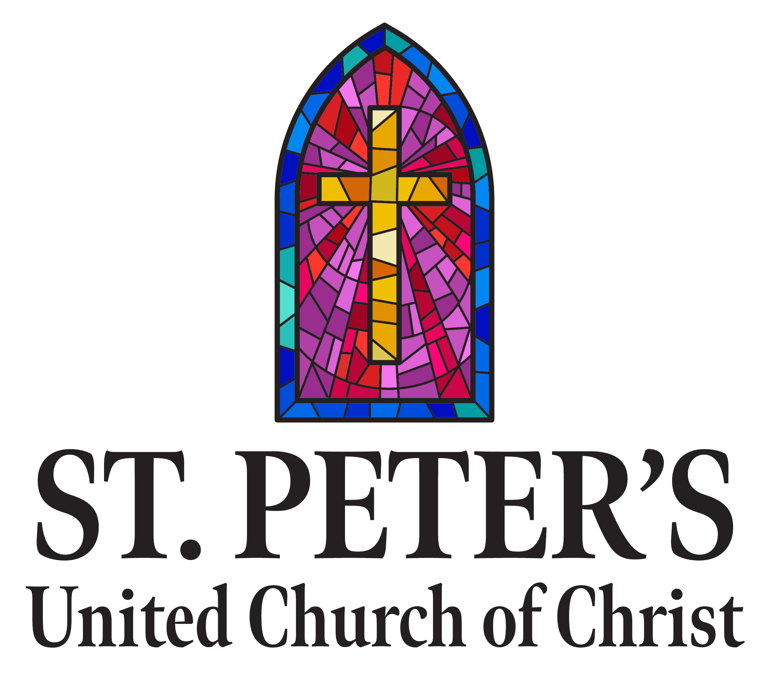

310 North Meadow Street (Grant Park, IL 60940)

Sunday School--9:00 a.m.
Sunday Morning Worship – 10:30 a.m.
Church Office – (815) 465-6191
Parsonage phone – (815) 466-4048 Pastor’s Cell – (567) 249-5130
Website: www.stpetersgp.org
Email: stpetersgp@sbcglobal.net
Facebook: St. Peters UCC Grant Park

Sunday, March 2nd, 2025
* In the way you are able, whether in body or in spirit, please rise.

Welcome & Announcements Neal Currier

Ringing of the Bell

Prelude “Love Was When” (Wyrtzen)

Lighting of the Candles Kaylie Meherg

*Call to Worship Neal Currier
Leader: The earth is the Lord’s! Everything in creation belongs to God.
People: Lift up your eyes! See the mighty works of the Lord!
Leader: This is the Lord’s house! All who hope in Him will
be called children of God.
People: Lift up your hearts! Receive the gracious gifts of the Lord!
Leader: This is the hour for worship and song.
People: Lift up your voice! Praise the Lord with all your might!

*Prayer of Invocation Pastor Kyle

*Opening Hymn “Praise Him! Praise Him!” #95

Scripture Reading Psalm 7:10-17 Neal Currier

Youth Choir Anthem “Easter Medley” (Johnson)

Children’s Message

Pastoral Prayer Pastor Kyle
Our Father, Who art in heaven, hallowed be Thy name. Thy kingdom come, Thy will be done, on earth as it is in heaven. Give us this day our daily bread, and forgive us our sins, as we forgive those who sin against us. And lead us not into temptation, but deliver us from evil. For Thine is the kingdom, and the power, and the glory, forever. Amen.

Worshipping God with our Offerings
Prayer of Dedication
Offertory “A Quiet Reflection” (Lasky)
*Gloria Patri #734

Scripture Reading Ephesians 1:1-10 Pastor Kyle

Hymn “Turn Your Eyes Upon Jesus” (sing twice) #472

Sermon “A Taste of God’s Love” Pastor Kyle

Celebration of the Lord’s Supper

*Closing Song “Pass It On” #557

*Benediction

*Postlude “The Heavens are Telling” (arr. Wells)

We at St. Peter’s are praying for:

Carter Fortin, Taylor Cleary, Dorothy Kutemeier, Judy Schneider, Pamela Nolan, Kristopher Meyer, Jeff Jones, Jackqueline Dupuis, Sandy & Ken Erickson, Tim Langlois, Ed & Anita Bush, Dornita Hamann, Tim Miller, Brad Fisher, Claudia Scott, Nancy Vittori, Betty Jones, Janet Harvey, Jillien Pettit, Cade McMartin, Colette Lawrence, and the family of Betty Buehler

We’re Trying Something New!

Scan the barcode with your phone to access today’s
Scripture readings and announcements!



Don’t have a phone? Still want a hard copy of the announcements?
That’s okay! ½ sheet inserts are available on the back table in the sanctuary with announcements. Feel free to pick one up!

May the Lord bless you and protect you!
May the Lord smile on you and be gracious to you!
May the Lord show you His favor and give you His peace!

Fusion Events (Youth Group for 6th-12th graders): For more details, visit our Facebook page or go to our church website at www.stpetersgp.org, (Under Ministries Section). You can also contact Josh (815) 693-5341.

Beecher Food Pantry: The pantry is looking for donations of toilet paper, paper towels, shampoo, pasta (all kinds), pasta sauce, tuna, canned chicken, pancake mix, pudding, and jello (regular and sugar free for both). Thank you.

I Love to Tell the Story: Have you heard the wonderful story of God's great love for humanity lately? As a new season of Lent is about to begin, we'd like to invite you to journey with us as we offer several opportunities to reflect, repent, and recharge your spiritual souls. Lent begins this week with our Ash Wednesday service (7 pm). On the following Wednesdays (03/12, 03/19, 03/26, 04/02, and 04/09), we will gather for soup and Scripture from 5:30 pm to 6:30 pm. If you would like to provide a soup, salad or dessert on any of these dates, please text/call Shirley Koehn at 708.254.2694. A short 30-minute service will begin at 6:30 in the Clyde Lange Fellowship Hall. On Sundays during Lent, Pastor Kyle will be preaching a series titled, "Everything (in) Between: Meeting God in the Midst of Extremes." More about Holy Week (April 13th - April 20th) will be shared soon.

Meeting God in the Midst of Extremes: We have several devotional books for Lent printed and available on the back table in the sanctuary. Please feel free to take one. If they run out, please let us know that you want one and we will print more. They are part of our Sunday Lenten series titled “Everything [in] between: Meeting God in the Midst of Extremes.”
Also, there will be daily devotions available on our church facebook page (St. Peters UCC Grant Park).

